Power Transmission Lines PhL 1.26.14

I added a short section on this subject after the twin lead example of Chapter 4.

I thought it would be good to gather a few facts on this subject.

This is from Rajput's google book on Power System Engineering

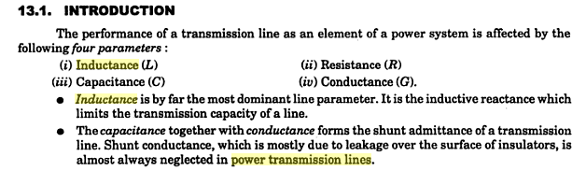
So we speak the same language. The claim is you can neglect G. One would compare ωC with G and you would think that with such low ω, G might matter. On the other hand,

C/G = ε/σ . (4.4.10)

≈ ε0/ σ ≈ 10-11/10-15 = 104 C (farads/m) = 104 G (mhos/m)

So compare the capacitative "admittance" to the conductive admittance

YC = ωC = 2πfC = 377 104 G ≈ 107 G

So this just says a lot more current flows across due to C than G, so you neglect G, even at 60 Hz. So you would be very wrong to think G + jωC ≈ G at "low frequency" of 60 Hz.

In my notation this says flux = Li I and Li = (μ0/8π). Raiput gets this result using some weird flux that I do not understand. It is through a thin math loop of width dr with long direction along z, so it actually captures some azimuthal B flux, but this guy says it all wrong. But I could verify that calculation in my Appendix C.
Raiput then does lots of multi-conductor geometries.

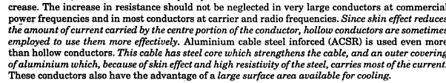

So how can that be? Let's compute δ for 60 Hz system:

δ ≡ $\sqrt{2/(ωμσ)}$ = δ ≡ $\sqrt{2/(377μ0σ)}$

δ2 = 2/[ 377 x 4π 10-7 * 5.8 107 ]

= 2000/377 * 10-3 * 103 ≈ 5.3 m2

δ = 2.3 meters!!!! wrong it is 1 cm!!! Do the math!

Who would ever have a line with a diameter in meters?? There might be some slight effect.

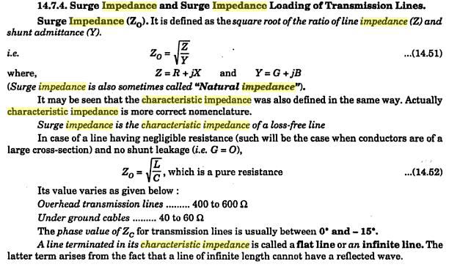

So they are claiming maybe 500 ohms, similar to twin lead which is 300 ohms. I guess even at 60 Hz we are still in the large ω limit so we have

Z0 = $\frac{Le}{C}$ = $\frac{(μ/4π)K}{4πε/K}$ = (1/4π) K $\sqrt{μ/ε}$ = (1/4π) K Zm = K * 30Ω

So power lines don't have crazy Z0 impedances. I have not yet seen how R and ωL compare.

So can I verify this claim quickly? R = σ/A = σ/(πa2), whereas

ωL = 2πf (μ0/4π)K = 2πf (10-7)K = 377 x 10-7 K = 0.4 x 10-4 K

But what is R for a power line wire? I see products from southwire where resistance
varys from .02 to .06 ohms per 1000 feet, amps ranging from 100 to 900. So lets go with

R = .02 ohms/1000ft * 3 ft/m = (.06/1000) ohms/m = .06 x 10-3 = 6 x 10-5 Ω/m

OK, now compare this to

ωL = 0.4 x 10-4 K = 4 x 10-5 K Ω/m

Now for twinlead style,

K = 4 ln(b/a) = 4 ln( 1m/ 1") = 4 ln(39) = 14.6 so then

ωL = 4 x 10-5 15 Ω/m = 6 x 10-4 Ω/m

So in my little ball park example, I find that ωL = 10R so you could roughly neglect R in this case.

So then we are justifying the idea that Z0 = $\sqrt{L/C}$ even at 60 Hz in power systems!!!

In my example you would have

Z0 = K * 30Ω = 14.6 * 30 = 438Ω, which is in the range 400-600Ω quoted above!

So I think I have grokked the basic power line parameters. The surprise is that Z0 is still in the high frequency limit!

Now suppose you put 12,000 volts on this 400Ω line which assume was properly terminated. Then

I = V/Z = 12000/400 = 30 amps = not very much, but

power = V2/R = I2R = 900 * 400 = 360 KW = 1/3 megawatt, could serve 180 houses say.

I think big lines are 230 to 800 KV so then

I = 230,000/400 = 575 amps ( Southwire had some up to 1000 amps)

power = I2R = 5752 400 = 132 megawatts.

Let's go back to the first example of 30 amps and 12000 volts. Then E = 12000 volts/m, that is an easy computation. What is B ?

2πrH = Ienclosed r = 1 cm say = 10-2m

H = I/2πr = 30amps/[ 2π 10-2m ] = 500 amp/m at the wire surface just due to one wire

So

E = 12000 volts/m
H = 500 amp/m ballpark numbers

curl H = (jωε + σ)E

So let's now think about the right angles argument. Assume σ = 0 for dielectric (air) then

curl H = jωε0E = C E C = 377 x 10-11 = 4 x 10-9

Then here is the argument:

E • H = [ curl H / jωε0] • H ≈ C-1 curl H • H

≈ 109 { ( ∂xHy - ∂yHx)Hz + ( ∂yHz - ∂zHy)Hx + ( ∂zHx - ∂xHz)Hy . }

≈ 109 Hy2 ∂z (Hx/Hy) if we assume Hz ≡ 0

= 0 since expect Hx/Hy = constant along transmission line

So the only way this baby can fail is if there is some small Hz which throws it off. Suppose there were some small Hz . then it is hard to know that E • H is. In terms of angle:

cosθ = 109 { ( ∂xHy - ∂yHx)Hz + ( ∂yHz - ∂zHy)Hx + ( ∂zHx - ∂xHz)Hy . } / $\sqrt{Hx2+ Hy2}$ E

Now suppose you ran a power line at 0.6 Hz instead of 60 Hz. Then since you are down ω by 100, the R would dominate in the R+jωL. The other thing G + jωC I don't know.

If the 109 were 1 instead, then your assumption would be roughly Hz << Hx or the like.

But if it is 109, then you have to assume that 109Hz << Hx which is probably not going to fly!

