General Capacitor Problem PhL 1.13.14

Start with this picture in 3D space

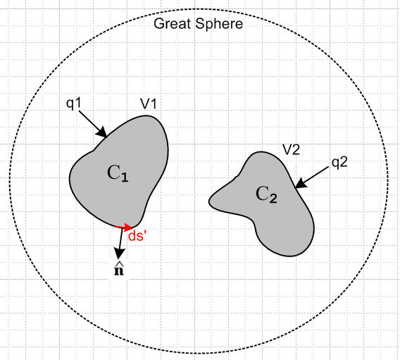

Viewed from infinity, we see basically two point charges of q1 and q2. The potential of each charge decays as 1/r at so φ(∞) = 0. Here is the Stakgold solution to this treated as a Dirichlet problem:

φ(x) = – ∫σ dSξ f(ξ) ∂ξng(x|ξ) // Stakgold (6.81) . (1.5.11)

= – ∫C1 dSξ V1 ∂ξng(x|ξ) – ∫ C2 dSξ V2 ∂ξng(x|ξ) – 0

= V1 F1(x) + V2F2(x) .

Then compute the E field at each conductor surface according to

En(x)|C1 = - ∂nφ(x)|C1 = - ∂n [V1 F11(x) + V2F12(x)] ≡ V1G11(x) + V2G12(x)

En(x)|C2 = - ∂nφ(x)|C2 = - ∂n [V1 F21(x) + V2F22(x)] ≡ V1G21(x) + V2G22(x)

where all functions are known. Then write

n1(x) = ε En(x)|C1 = εV1G11(x) + εV2G12(x)

n2(x) = ε En(x)|C2 = εV1G21(x) + εV2G22(x)

Then integrate to get

q1 = C1 ds' n1(x) = εV1H11 + εV2H12 = V1 C11 + V2C12
q2 = C2 ds' n1(x) = εV1H21 + εV2H22 = V1C21 + V2 C22

where suddenly Smythe's mutual capacitances appear. Then we have

$\left(\begin{matrix}q1 \\ q2\end{matrix}\right)$ = $\left(\begin{matrix}C11 & C12 \\ C21 & C22\end{matrix}\right)$$\left(\begin{matrix}V1 \\ V2\end{matrix}\right)$ or q = C V

Invert to get

$\left(\begin{matrix}V1 \\ V2\end{matrix}\right)$ = C-1$\left(\begin{matrix}q1 \\ q2\end{matrix}\right)$ = S $\left(\begin{matrix}q1 \\ q2\end{matrix}\right)$ = $\left(\begin{matrix}S11 & S12 \\ S21 & S22\end{matrix}\right)$$\left(\begin{matrix}q1 \\ q2\end{matrix}\right)$

Now set q1 = q and q2 = -q and then

$\left(\begin{matrix}V1 \\ V2\end{matrix}\right)$ = C-1$\left(\begin{matrix}q \\ -q\end{matrix}\right)$ = $\left(\begin{matrix}S11 & S12 \\ S21 & S22\end{matrix}\right)$$\left(\begin{matrix}q \\ -q\end{matrix}\right)$ = q $\left(\begin{matrix}S11 & S12 \\ S21 & S22\end{matrix}\right)$$\left(\begin{matrix}1 \\ -1\end{matrix}\right)$ = q $\left(\begin{matrix}S11- S12 \\ S21-S22\end{matrix}\right)$

so then

V1 = q (S11- S12)
V2 = q (S21- S22)

And then

V = V1- V2 = q (S11- S12) - q (S21- S22)

= q [ (S11- S12) - (S21- S22)]

= q [S11- S12 - S21+ S22]

= q [S11+ S22 - 2S12]

so the capacitance is given by

C = 1/(S11+ S22 - 2S12)

Great, now I want to see someone verify this whole idea of mine.

By the way,

C = S-1 = cof(CT)/det(C)

Now it happens that I know how to invert a 2x2 matrix. Suppose we have

C = $\left(\begin{matrix}C11 & C12 \\ C21 & C22\end{matrix}\right)$

Then

S = C-1= $\left(\begin{matrix}C22 & -C12 \\ -C21 & C11\end{matrix}\right)$/det(C)

Then

S11 = C22 /det(C)
S22 = C11 /det(C)

C = 1/(S11+ S22 - 2S12)

C-1 = (S11+ S22 - 2S12)

= (C22+ C11 - 2[-C12])/det(C)

= $\frac{C11+ C22 + 2C12}{C11C22 - C122}$

And then

C = $\frac{C11C22 - C122}{C11+ C22 + 2C12}$

And here is a slight with 100% verification!! hurray!

