This is the Title PhL 3.26.05

This is installed.

Chapter 6: Transmission Lines with Two Circular Conductors 1
6.1 A candidate transverse potential φ_{t} 1
6.2 Ancient Greece circa 230 BC 1
6.3 Back to the Future: Calculation of K 4
6.4 Summary of Results 11

Chapter 6: Transmission Lines with Two Circular Conductors

6.1 A candidate transverse potential φt

In the previous chapter (both Section 5.3 (b) and Section 5.4 (b)) we showed that the transverse potential of a 2-conductor balanced transmission line must have this form when viewed from far away,

φt(x) ≈ ln(s22/s12) // limiting form as point x = (x,y) moves far from the conductors
(5.3.11)
s12 = (x-x1)2 + (y-y1)2 = |x - x1|2
s22 = (x-x2)2 + (y-y2) = |x - x2|2 (6.1.1)

where the points x1 and x2 are the "center of charge" points for the C1 and C2 conductor cross sections.

Suppose now we take as a candidate dimensionless transverse potential φt exactly the above limiting expression. Our candidate φt is

φt(x) = ln(s22/s12) . for all values of r, close and far (6.1.2)

where we specify that our center of charge points are x1 = (d,0) and x2 = (-d,0).

Certainly this meets our limiting form boundary condition (5.3.11)! We know also that this potential is a valid solution of the 2D Laplace equation, since ln(s1) and ln(s2) are each valid solutions. This fact was shown at the start of Section 5.4 (b). Since -2πlns1 is the 2D free-space propagator, it follows that
-2πlns1 is a solution of ∇22D(φ) = 0 away from the point where s1 = 0, and then so is lns1. Then by superposition, 2lns2 - 2lns1 is also a valid solution, and this is ln(s22/s12). Thus, our φt is a valid candidate for a lossless transmission line since for such a transmission line φt satisfies the 2D Laplace equation according to (5.4.3),

∇t2 φt(x,y) = 0 φt(C1) = K1 φt(C2) = K2 K1-K2 = K . (5.4.3)

The question then becomes: what are the surfaces Ci in 2D space on which this candidate φt is a constant? Such surfaces can then serve as possible conductor cross sections for a transmission line.

6.2 Ancient Greece circa 230 BC

Apollonius of Perga (262BC-190BC) [ like Joe of Chicago ] was a pretty smart guy as wiki explains. He did astronomy and therefore he did geometry. Besides giving conic sections their current names and writing eight books about them, he learned about what are now called the Apollonian Circles. These circles form the "level surfaces" for 2D bipolar (orthogonal) coordinates as shown in this picture
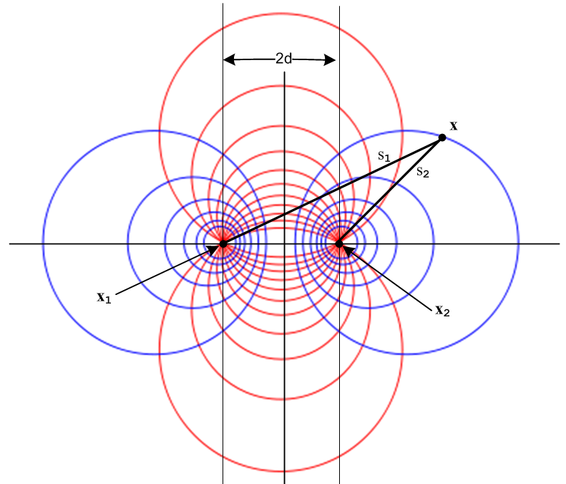 Fig 6.1
http://en.wikipedia.org/wiki/Apollonian_circles

When this picture is rotated around its vertical axis, the blue level circles become toroids and one then arrives at 3D toroidal coordinates, but that is another story. Our interest is in the 2D blue circles.

It turns out, as the reader may suspect, that the blue circles have the following simple property:

s2/s1 = constant

which we shall prove in a moment. Calling this constant e-B we get

s2/s1 = e-B => ln(s2/s1) = - B . (6.2.1)

Thus, since φt(x) = ln(s22/s12) = 2 ln(s2/s1), the blue circles are candidate equipotential surfaces for our potential φt(x) !

To show that s2/s1 = e-B describes a circle, consider:

|x-x2| / |x-x1| = e-B

|x-x2|2 = e-2B |x-x1|2

(x-x2)2 + (y-y2)2 = e-2B [(x-x1)2 + (y-y1)2 ] .

This equation has the following form

A(x2 + y2) + Bx + Cy + D = 0 A = (1-e-2B)
or
x2 + y2 + αx + βy + γ = 0 .

One can then "complete the squares" to obtain the equation of a circle of radius r centered at (xc,yc) ,

(x - xc)2 + (y - yc)2 = r2

where -2xc = α -2yc= β xc2 + yc2 - r2 = γ . (6.2.2)

For our particular locations of x1 and x2 shown in Fig 6.1, we have

x1 = -d x2 = d y1 = y2 = 0
s12 = (x+d)2 + y2 s22 = (x-d)2 + y2 (6.2.3)
so
s2/s1 = e-B => s1/s2 = eB => e2Bs22 = s12 => (eB/2) s22 = (e-B/2) s12 =>

(eB/2) [x2 - 2dx + d2 + y2] = (e-B/2) [x2 + 2dx + d2 + y2]

shB (x2+d2+y2) + chB(-2dx) = 0 // shB = (eB-e-B)/2, chB = (eB+e-B)/2

(x2+d2+y2) + cothB (-2dx) = 0

x2 - 2d x cothB + y2 = -d2

x2 - 2d x cothB + d2coth2B + y2 = -d2+ d2coth2B // complete the square

(x - dcothB)2 + y2 = d2csch2B . (6.2.4)

We conclude that our blue equipotential circles have this simple form

(x - xc)2 + y2 = r2 xc = d cothB r = |d cschB| (6.2.5)

Using d = 5, here is a plot of these circles for 10 different B values:

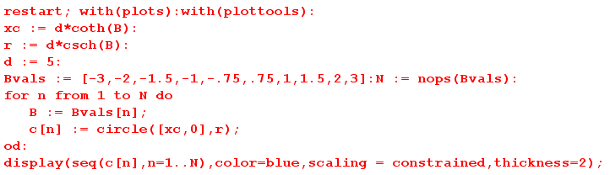

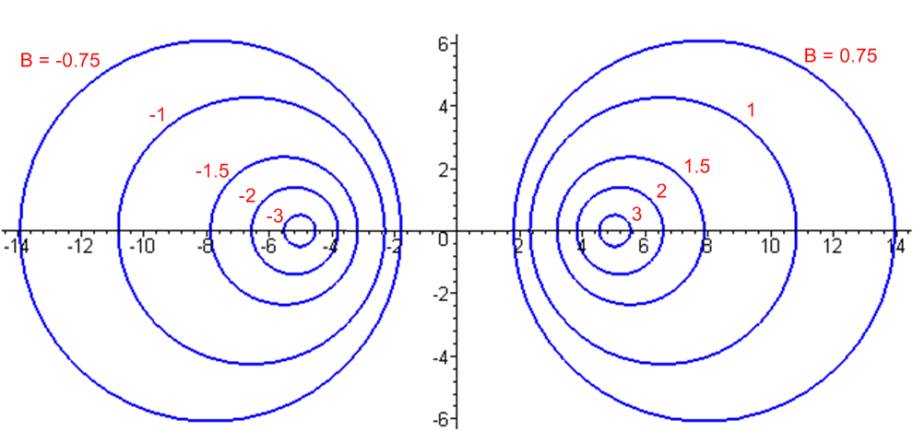 Fig 6.2

Since xc = d cothB, the right side curves have B > 0 while the left side have B < 0. The value B = 0 corresponds to the vertical y axis, while B = ±∞ correspond to the two focal points at d = ± 5.

6.3 Back to the Future: Calculation of K

We select C2 to be a circle on the right side, so that B2 > 0.
For C1 we select a second circle from either the left or the right, so B1 can have either sign.

If we select C1 from the left side, we have a two-wire transmission line(dielectric = gray),

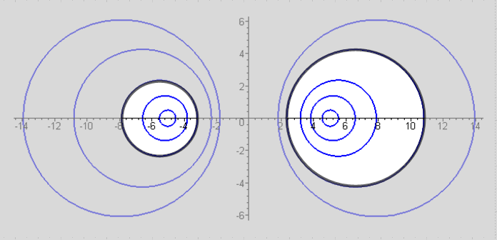 Fig 6.3

If we select C2 from the right, we have an off-center coaxial transmission line.

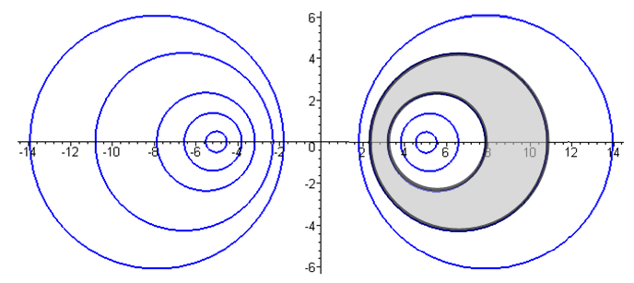 Fig 6.4

Fig 6.3 shows a transmission line cross section where the two conductors are round wires with unequal radii a1 and a2. Treated as a 2D capacitor, one's intuition at least suggests that the two focal points might be the conductor "centers of charge". The dielectric is of course outside the two conductors and it is possible to select a point in the dielectric that is "far away" from both conductors, so our limiting form discussion applies and the points x1 and x2 should be the centers of charge.

Figure 6.4 shows an off-center coaxial transmission line for which the dielectric is the region between the two black circles. In this case, one cannot take a point in the dielectric that is "far away" from both conductors, so the limiting form discussion does not apply. Here it appears that both conductors have the same center of charge located at x2.

We shall now determine K and therefore the 2D capacitance C = 4πε/K for the above cases.

Let σ1 = sign(B1). We then have

φt(x) = ln(s22/s12) = 2 ln(s2/s1)

φt(C1) = 2 ln(s2/s1)|C1 = -2B1
φt(C2) = 2 ln(s2/s1)|C2 = -2B2 . (6.3.1)

Recall from (5.1.3) that φt(C1) - φt(C2) = K. Therefore,

K = 2(B2-B1) = 2 (|B2| -σ1|B1|). (6.3.2)

Once we know K, we know C, G and Le for the transmission line from (4.11.30).

We must now do some slightly painful algebra. First, we know from (6.2.5) that

a1 = d |cschB1| => (d/a1) = sh(|B1|) => |B1| = sh-1(d/a1)
a2 = d |cschB2| => (d/a2) = sh(|B2|) => |B2| = sh-1(d/a2) (6.3.3)

The separation of the centers of the two round wires is b, where

b = |xc2 - xc1| = |d cothB2 - dcothB1| = d |cothB2 - cothB1| (6.3.4)

From (6.3.2) we write

ch(K/2) = ch [|B2| -σ1|B1|]

= ch|B2| ch|B1| - σ1 sh|B2| sh|B1|

= $\sqrt{1+sh2B2}$$\sqrt{1+sh2B1}$ - σ1 sh|B2| sh|B1|

= $\sqrt{1+(d/a2)2}$$\sqrt{1+(d/a1)2}$ - σ1 (d/a2) (d/a1) . (6.3.5)

Meanwhile,

b = d |cothB2 - cothB1| = |d [ chB2/shB2 - chB1/shB1] | = |d [ ch|B2|/sh|B2| - σ1ch|B1|/sh|B1|] |

= | d [ch|B2| sh|B1| - σ1 ch|B1| sh|B2| ] / sh|B1| sh|B2| |

= | d [$\sqrt{1+(d/a2)2}$(d/a1) - σ1 $\sqrt{1+(d/a1)2}$ (d/a2) ] / (d/a2) (d/a1) |

= | [$\sqrt{1+(d/a2)2}$(1/a1) - σ1 $\sqrt{1+(d/a1)2}$ (1/a2) ] / (1/a2) (1/a1) |

= | [a2 $\sqrt{1+(d/a2)2}$- σ1 a1 $\sqrt{1+(d/a1)2}$ ] | . (6.3.6)

Square this to get

b2 = a22[1+(d/a2)2] + a12[1+(d/a1)2] - 2σ1a1a2$\sqrt{1+ (d/a2)2}$$\sqrt{1+ (d/a1)2}$
so
2 σ1a1a2$\sqrt{1+ (d/a2)2}$$\sqrt{1+ (d/a1)2}$ = a22[1+(d/a2)2] + a12[1+(d/a1)2] - b2

= a22 + d2 + a12 + d2 - b2 = a12 + a22 + 2d2 - b2 .

The purpose of doing this is to obtain the following expression for the radical product,

$\sqrt{1+ (d/a2)2}$$\sqrt{1+ (d/a1)2}$ = (a12 + a22 + 2d2 - b2) / (2 σ1a1a2 ) . (6.3.7)

We now install this into our expression (6.3.5) above for ch(K/2) to get

ch(K/2) = $\sqrt{1+(d/a2)2}$$\sqrt{1+(d/a1)2}$ - σ1 (d/a2) (d/a1)

= (a12 + a22 + 2d2 - b2) / (2 σ1a1a2 ) - 2d2/ (2σ1a2a1)

= (a12 + a22 - b2) / (2σ1a2a1) = σ1 (1/2) (a12 + a22 - b2)/(a1a2)

= σ1 (1/2) [ (a1/a2) + (a2/a1) - (b2/a1a2) ] (6.3.8)

and the focal distance d has vanished from our expression. Therefore

K = 2 ch-1 { σ1 (1/2) [ (a1/a2) + (a2/a1) - (b2/a1a2) ] } (6.3.9)

Notice that the result is symmetric under a1 ↔ a2 .

We now distinguish our two cases of interest. For the unequal twin-lead type transmission line of Fig 6.3 we know that B1 < 0 since the C1 circle is on the left, so σ1 = sign(B1) = - 1 and then

K = 2 ch-1 { (1/2) [ (b2/a1a2) - (a1/a2) - (a2/a1)] } // Fig 6.3 (6.3.10)

which is an amazingly simple result. Recall from (4.4.16) that

Z0 = (K /$\sqrt{εrel}$) 30Ω (4.4.16)

so then

Z0 = ch-1 { (1/2) [ (b2/a1a2) - (a1/a2) - (a2/a1)] } (1/$\sqrt{εrel}$) 60 Ω . (6.3.11)

If the wires have diameters d1 = 2a1 and d2 = 2a2 this becomes

Z0 = ch-1 { (1/2) [ (4b2/d1d2) - (d1/d2) - (d2/d1)] } (1/$\sqrt{εrel}$) 60 Ω . (6.3.12)

For verification, we quote again from Reference RDE page 29-23,

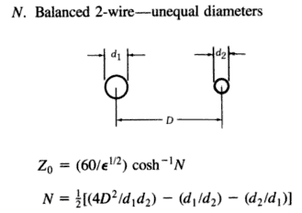

where our b is called D.

On the other hand, if we are interested in an off-center coaxial transmission line as in Fig 6.4, we select C1 from the right side of Fig 6.2 and then σ1 = sign(B1) = +1 and we find

K = 2 ch-1 { (1/2) [ (a1/a2) + (a2/a1) - (b2/a1a2) ] } // Fig 6.4 (6.3.13)

Z0 = ch-1 { (1/2) [ (a1/a2) + (a2/a1) - (b2/a1a2) } (1/$\sqrt{εrel}$) 60 Ω (6.3.14)

Z0 = ch-1 { (1/2) [ (d1/d2) + (d2/d1) - (4b2/d1d2) } (1/$\sqrt{εrel}$) 60 Ω (6.3.15)

For verification, we quote again from Reference RDE page 29-24,

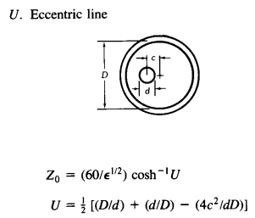

where we may take d = our d1 and D = our d2 and c = our b = the center-line separation.

There is one more case of interest that falls out from this analysis. If we take B1 = 0 we have

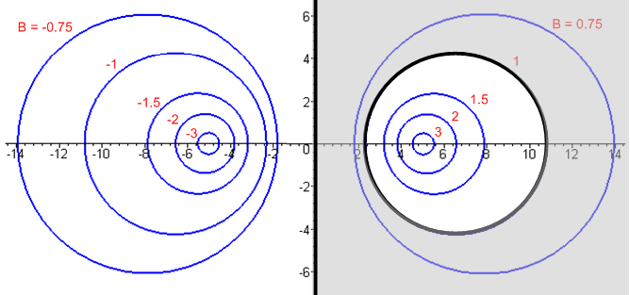 Fig 6.5

which is a transmission line consisting of a round wire above an infinite flat plane. This is a tricky limit of (6.3.10) where both a1→∞ and b→∞, so we ignore those expressions and work from scratch. Since B1 = 0 we find from (6.3.2) that

K = 2B2 . (6.3.16)

We know from (6.2.5) that

x2c = d coth B2 = d chB2/shB2
a2 = d/sh(B2) . (6.3.17)

Therefore

x2c/a2 = chB2 => B2 = ch-1(x2c/a2) => K = 2 ch-1(x2c/a2) . (6.3.18)

Here x2c is the distance from the wire center line to the ground plane. If we call this h and the wire radius a, we then have the following extremely simple and exact result,

K = 2 ch-1(h/a) // wire radius a with center h over ground plane, exact
Z0 = (K /$\sqrt{εrel}$) 30Ω = ch-1(h/a) (1/$\sqrt{εrel}$) 60 Ω (6.3.19)

where of course we must have h > a to keep the wire from touching the ground plane. Using the identity ch-1x = ln(x + $\sqrt{x2-1}$) for x ≥ 1 we can write the above as

K = 2 ln [ (h/a) + $\sqrt{(h/a)2-1}$] // wire radius a with center h over ground plane, exact
Z0 = ln [ (h/a) + $\sqrt{(h/a)2-1}$] (1/$\sqrt{εrel}$) 60 Ω (6.3.20)

For h >> a this becomes ("thin wire")

K = 2 ln(2h/a) // wire radius a center h over ground plane, h>> a
Z0 = ln(2h/a) (1/$\sqrt{εrel}$) 60 Ω (6.3.21)

For verification, we found the following web offering (where log means ln ),

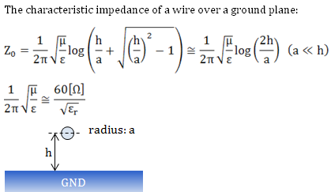

http://members3.jcom.home.ne.jp/zakii/tline_e/14_microstripline_z0.htm

which results are derived using an image method to handle the ground plane.

For some odd reason, our usual RDE source on this subject only gives the result for h >> a . Taking d to be the wire diameter,

Z0 = ln(4h/d) (1/$\sqrt{εrel}$) 60 Ω

= ln(10) log (4h/d) (1/$\sqrt{εrel}$) 60 Ω

≈ log (4h/d) (1/$\sqrt{εrel}$) 138.2 Ω (6.3.22)

which then compare to RDE p 29-22 ,

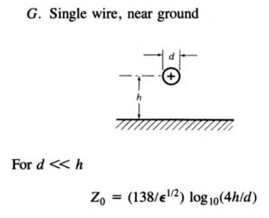

Reader Exercise: Given φ(x) = ln(s22/s12), compute E = -∇φ , compute En = E • as the normal electric field at the surface of C2, compute n = εEn as the linear charge density on C2, then using that n, find the "center of charge" <x> = [ ∫C2 ds x n(x) ds / ∫C2 ds n(x) ] and see if <x> = d. Decide whether or not it is worth while learning how to work in bipolar coordinates to carry out this exercise.

6.4 Summary of Results

Summary for Transmission Line with Two Round Conductors (6.3.23)

Identities: ch-1x = ln(x + $\sqrt{x2-1}$) , x ≥ 1 ch-1x ≈ ln(2x), x >> 1
ch-1[$\frac{1}{2}$($\frac{a}{b}$ + $\frac{b}{a}$)] = sign(b-a)ln $\frac{b}{a}$ a > 0 and b > 0 (4.6.6)
Line Properties: C = 4πε/K G = 4πσ/K Le = $\frac{μ}{4π}$ K ε,σ,μ for dielectric
_____________________________________________________________________________________

K = 2 ch-1 { (1/2) [ (b2/a1a2) - (a1/a2) - (a2/a1)] }
ai = radii b = center separation
Special case a1 = a2 = a: K = 2 ch-1 [ (b2/2a2) - 1] (twin-lead)
Special case b >> a1,a2: K = 4 ln(b/$\sqrt{a1a2}$)
Special case b >> a1=a2=a: K = 4 ln(b/a)

_____________________________________________________________________________________
K = 2 ch-1 { (1/2) [ (a1/a2) + (a2/a1) - (b2/a1a2) ] }
ai = radii b = center separation
Special case b = 0 and a2> a1: K = 2 ln(a2/a1) (centered coaxial)
_________________________________________________________________________________

K = 2 ch-1(h/a) = 2 ln [ (h/a) + $\sqrt{(h/a)2-1}$]
a = radius h = height of center over plane
Special case h >> a: K = 2 ln(2h/a) (thin wire)

