2D Green's Function for Two Circles PhL 1.10.14

This is early work which is now all installed into Chapter 6, the guy from Perga and all that stuff. I think I just started over in Chapter 6 and ignored what is below.

1. First, I plan to use 2D bipolar coordinates, M&S picture of this is page 64 Fig 2.09. horizontal circles are labeled by u, vertical circles by v. This is extruded into a cylindrical coordinate system on page 81 system E4C where they are then called bi-cylindrical coordinates with that same Fig 2.09 mentioned. But here they write

x = ashη/(chη-cosψ)
y = asinψ/(chη-cosψ)
z = z

g11 = g22 = a2/(chη-cosψ)2 g33 = 1

h1 = h2 = a/(chη-cosψ) h3 = 1

Then on page 89 M&S give the differential operators including

∇2 = [(chη-cosψ)2/a2] (∂η2 + ∂ψ2) + ∂z2

From this I then know that

∇22D = [(chη-cosψ)2/a2] (∂η2 + ∂ψ2)

Now I have to figure out how the various thing's are labeled! This really is the same as toroidal if you set φ = 0, and I have lots of data on that.

2. Using my "toroidal coordinates.doc" notes I will switch now to my usual coordinates,

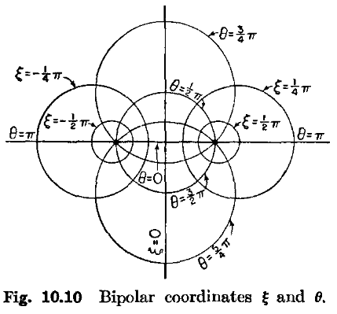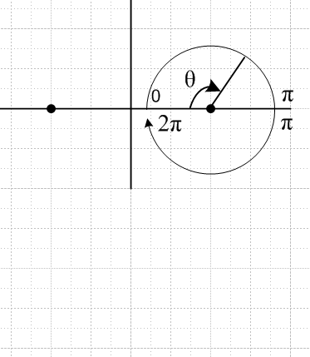
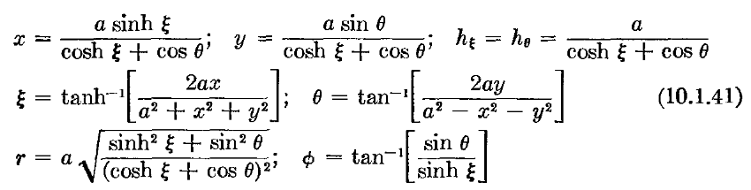

I then go on to get the Cartesian equations of the circles.
I next change the meaning of θ to the following

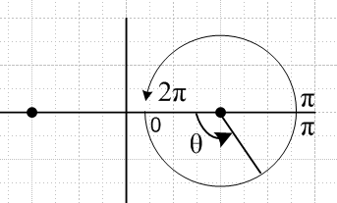

and after this my equations become

x = ashξ/(chξ+cosθ) hξ = hθ = a/(chξ+cosθ) -y/x = sinθ/shξ
-y = asinθ/(chξ+cosθ)

ξ = tanh-1[2ax/(a2+ x2+ y2)]
θ = tan-1[ -2ay/(a2-x2-y2)]

r2 = a2 (sh2ξ + sin2θ) / (chξ+cosθ)2 tanφ ≡ y/x = -sinθ/shξ

x2 + (y - acotθ)2 = a2/sin2θ yc = a cot(θ) R = a/|sinθ|

I then change from θ to u like so

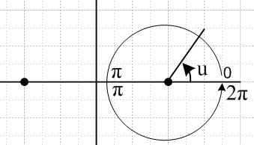

and here are the new equations.

x = ashξ/(chξ–cosu) hξ = hu = a/(chξ–cosu) y/x = sinu/shξ
y = asinu/( chξ–cosu)

ξ = tanh-1[2ax/(a2+ x2+ y2)]
tanu = [ -2ay/(a2-x2-y2)]

r2 = a2 (sh2ξ + sin2u) / (chξ-cosu)2 tanφ ≡ y/x = sinu/shξ

x2 + (y- acotu)2 = a2/sin2u yc = a cot(u) R = a/|sinu|
(x - acothξ)2 + y2 = a2/sh2ξ xc = acothξ R = a/|shξ|

THESE equations then match those of M&S and then I presume that

∇2 = [(chξ-cosu)2/a2] (∂ξ2 + ∂u2) + ∂z2

∇22D = [(chξ-cosu)2/a2] (∂ξ2 + ∂u2)

The Apollonius horizontal circles are labeled by ξ (the toroid label). So my capacitor circles are going to be surfaces of constant ξ. Values are negative for left side circles, positive for right side. Then I guess my little lines doc Chapter 5 equation becomes

[(chξ-cosu)2/a2] (∂ξ2 + ∂u2)φt(ξ,u) = 0 φt(ξ1) = K/2 φt(ξ2) = -K/2

Now here then is the Green's function problem

[(chξ-cosu)2/a2] (∂ξ2 + ∂u2)g(ξ,u|ξ',u') = δ(ξ-ξ')δ(u-u') (1/J) ??

Let's start in Cartesians

-(∂x2 + ∂y)2g(x,y|x',y') = δ(x-x')δ(y-y')

If we wanted to go to polar coordinates, we would have h1 = r and h2 = 1 ( think) and then

dV = rdrdθ = J drdθ = dxdy

x = rcosθ J = r
y = rsinθ δ(x-x')δ(y-y') = (1/r)δ(r-r')δ(θ-θ') = δ(r-r')δ(θ-θ')(1/J)

Now start again in Cartesians and go to bipolar coordinates. In this case

J = [a/(chξ–cosu)]2 = h1h2, and so we get

-[(chξ-cosu)2/a2] (∂ξ2 + ∂u2)g(ξ,u|ξ',u') = δ(ξ-ξ')δ(u-u') [(chξ-cosu)2/a2]

so the factor cancels on both sides and we end up with

-(∂ξ2 + ∂u2)g(ξ,u|ξ',u') = δ(ξ-ξ')δ(u-u')

Do I believe this, it seems just too easy. It is identical to 2D Cartesian!

In lines Appendix I I show that in 2D,

-∇2[ln(1/R)/2π] = δ(r-r') R = | r - r' | (I.1.4)

Now I suppose in bipolar coordinates this says

[(chξ-cosu)2/a2] (∂ξ2 + ∂u2) { - ln(1/R)/2π } = δ(ξ-ξ')δ(u-u') [(chξ-cosu)2/a2]

or

- (∂ξ2 + ∂u2) { ln(1/R)/2π } = δ(ξ-ξ')δ(u-u')

where you have to write our R in terms of the bipolar coordinates.

x = ashξ/(chξ–cosu)
y = asinu/( chξ–cosu)

x' = ashξ'/(chξ'–cosu')
y' = asinu'/( chξ'–cosu')

R2 = (x-x')2 + (y-y')2 = [ashξ/(chξ–cosu) - ashξ'/(chξ'–cosu')]2

+ [asinu/( chξ–cosu) - asinu' /(chξ'–cosu')]2

= a2(chξ–cosu)-2(chξ'–cosu')-2

{ [shξ(chξ'–cosu') - shξ'(chξ–cosu)]2 + [ sinu(chξ'–cosu')-sinu'(chξ–cosu)]2

Maple says this is a big mess. What am I doing wrong here? I looked on the web and found some very messy Green's Functions in the presence of two circles, so maybe I don't really want to go down this path.

