Old Sections 6.5 (b) and (c) PhL 10.7.14

Replaced by new text on 10.7.14.

(b) The Proximity Effect

Appendix D computes the E fields inside a round wire of radius a in terms of the surface charge moments ηm under the assumption that a wave ej(ωt-kz) is traveling down the wire. We first remind the reader of the parameters involved. From (D.2.2),

β'2 ≡ β2 - k2 (D.2.2)
where
β = ej3π/4 ($\sqrt{2}$/δ) = (j-1) / δ = ej3π/4 $\sqrt{ωμσ}$ (2.2.30)
k = -j$\sqrt{zy}$= -j $\sqrt{(R+jωL)(G+jωC)}$ . (5.3.5) (6.5.8)

Here β is the wavenumber in the conductor medium shown in (1.5.1c), while k is a low-loss effective wavenumber for the transmission line wave having the form ej(ωt-kz). Although k is a free parameter in Appendix D, it is forced equal to -j$\sqrt{zy}$ in Chapter 5 where the Helmholtz equation is separated into longitudinal and transverse parts. This identification k = -j$\sqrt{zy}$ is established only for high frequencies ( = low-loss), but can be assumed approximately true at lower frequencies. This subject is discussed in detail in Section D.11 (a), and the high and low ω limits of k are obtained in Appendix Q. At high ω one sees that

k ≈ -j$\sqrt{(jωL)(jωC)}$ = -jω$\sqrt{-LC}$= +ω$\sqrt{LC}$ ≈ ω$\sqrt{LeC}$ = ω/vd ≡ βd0 (4.12.26)

β'2 ≡ β2 - k2 ≈ -jωμσ - βd02 ≈ -jωμσ = β2

where we identify 1/$\sqrt{LC}$with vd, the speed of light in the dielectric, as shown in (4.12.19). The fact that β2 = -jωμσ is shown below (D.2.2) to be valid for f << 1018 Hz, so for any reasonable large ω we do have

β' = β = ej3π/4 ($\sqrt{2}$/δ) = (j-1) / δ = ej3π/4 $\sqrt{ωμσ}$. (6.5.9)

Now, since n(θ) is real and an even function of θ for our two-cylinder transmission line, η-m = ηm and from (D.10.4a) the longitudinal field Ez(r,θ) is shown to be

Ez(r,θ) = (1/4) I Rdc (aβ') [ f0(r) + 2 Σm=1∞ fm(r) ηm cos(mθ) ] . (D.10.4a)

Using (6.5.4) for the ηm we then get

Ez(r,θ) = I Rdc (βa/4) [ f0(r) + 2 Σm=1∞ (-1)m e-m|ξ$_{1}$| fm(r) cos(mθ) ] (6.5.10)

and then, since Rdc = (1/πa2σ),

Jz(r,θ) = σ Ez(r,θ) = (I/πa2)(βa/4) [ f0(r) + 2 Σm=1∞ (-1)m e-m|ξ$_{1}$| fm(r) cos(mθ) ]

where
fm(r) ≡ [$\frac{Jm(x)}{Jm+1(xa)}$ - $\frac{Jm(x)}{Jm-1(xa)}$ ] x = βr xa = βa β = ej3π/4 ($\sqrt{2}$/δ) . (6.5.11)

This is the longitudinal current density in the left round conductor (the one with ξ1 < 0) and just the fact that it is not constant in θ shows that we have a proximity effect as illustrated in Fig 6.6 above. We refer to this current density Jz as being "asymmetric" as opposed to "uniform".

(c) Plots of the Proximity and Skin Effects

First, it is helpful to have a plot showing the conductors for various values of ξ so one can get a feel for how "fat" the cylinders are relative to their separation distance (same as Fig 6.2),

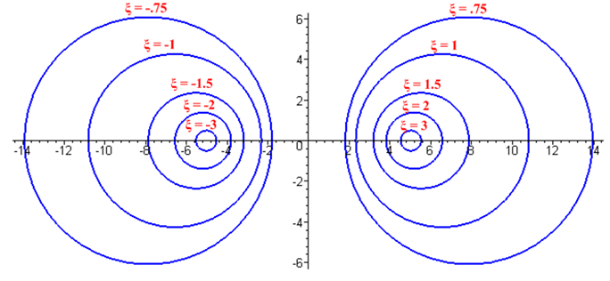
Bipolar (2.5) Fig 6.10
From (6.5.11), using Jdc= (I/πa2),

Jz(r,θ) = Jdc (βa/4) [ f0(r) + 2 Σm=1∞ (-1)m e-m|ξ$_{1}$| fm(r) cos(mθ) ] . (6.5.12)

In Maple code we first enter all the expressions of interest:

Jz = (6.5.12) β = (6.5.9) fm = (6.5.11) ηm = (6.5.4) x = βr xa = βa

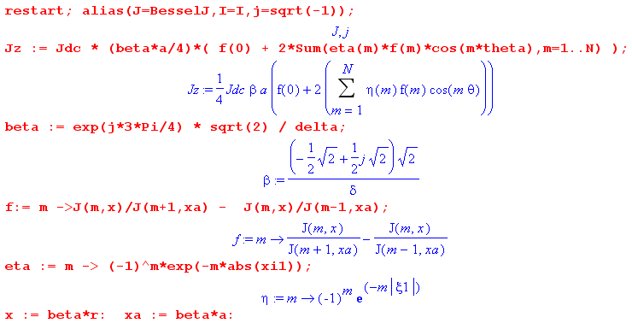

Next, specific parameters are entered (xi1 = ξ1 = -1 and δ/a = 1/10),

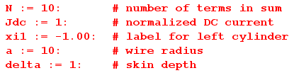

The first plot is of |Jz(r,θ)| where the axes are r and θ :

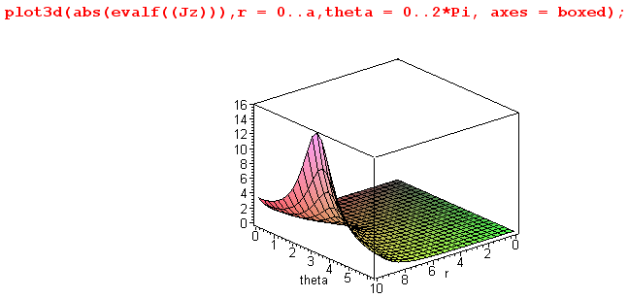 Fig 6.11

This shows the general peaking of |Jz(r,θ)| at θ = π (see Fig 6.7) , but the plot we really want to see is |Jz(r,θ)| displayed over the cross section of the round wire:

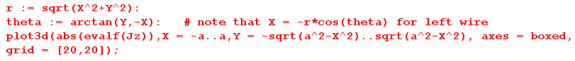

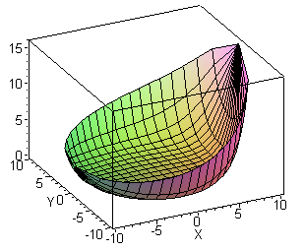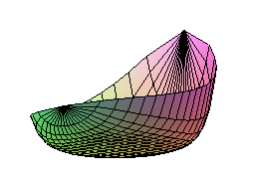
|Jz| Distribution in left round wire for a = 10, δ = 1 and ξ1 = - 1.00 Fig 6.12

Observations:

• Skin effect for |Jz| appropriate to δ/a = 1/10 is seen in the cross section. The "bottom" of the plot is flat at value 0 and indicates no current in the central conductor region -- all current is in the sheath of thickness ≈ 1 just inside the wire radius a = 10.

• The distribution is strongly peaked on the side of the conductor facing the other conductor; this is the proximity effect (currents in opposite directions).

• Using the formula given in (P.10.7),

R = Rdc $\frac{E(Jz2)}{[E(Jz)]2}$ , (P.10.7)

one can compute the effect wire resistance R > Rdc using (6.5.11) for Jz. The high and low ω limits of fm and Jz = σEz appearing in Appendix D.10 and D.11 simplify this task if those limits are of interest.

We now present a few such plots for different values of δ and ξ1. First, for δ/a = 1/10 and ξ1 = -3 :

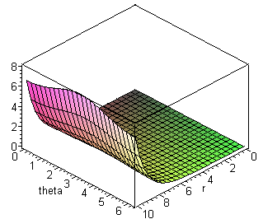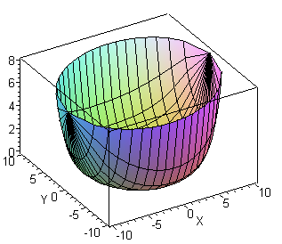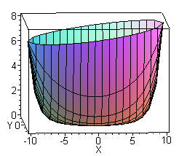

|Jz| Distribution in left round wire for a = 10, δ = 1 and ξ1 = - 3.00 Fig 6.13

Here, for two equal-radius round wires of ξ1= -3 and ξ2= 3, the wires are "far apart" (see Fig 6.10 above). The proximity effect is still present as shown in the rightmost picture (larger at x = 10 than at x = -10), but the effect is small. On the other hand, the skin effect is still strongly in evidence, and again the entire current is in a sheath just inside r = a = 10 of thickness about δ = 1 unit.

Next is an example with δ/a = 1/2 and ξ1 = -1 :

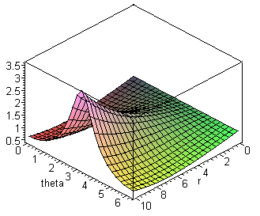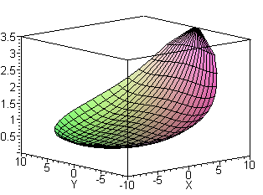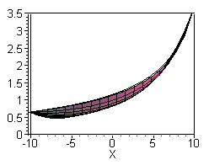

|Jz| Distribution in left round wire for a = 10, δ = 5 and ξ1 = - 1.00 Fig 6.14

In the central drawing we are looking into the bowl of the distribution from above. Since δ/a = 1/2 now, the skin effect is much less pronounced: Jz is no longer 0 in the central region as shown on the right. There is only a shallow "lip" around the bowl edge suggesting some skin effect. On the other hand, the proximity effect is still strong since for ξ1 = -1 and ξ2 = 1 the wires are fairly close together as shown in Fig 6.10. For such wires, using (6.5.6),

a/b = a1/b = $\frac{|cschξ1|}{cothξ2-cothξ1}$ = $\frac{|csch(-1)|}{coth(1)-coth(-1)}$ = $\frac{csch(1)}{2 coth(1)}$ = $\frac{1}{2cosh(1)}$ = 0.324

==> b/a = 3.08 and b/(2a) = 1.54

so the ratio of wire center separation to wire diameter is about 1.5 (which agrees with ruler measurements made on Fig 6.10 above). The two conductors touch when this ratio drops to 1.0.

In the next plot, we have a = 10 and δ = 1, but now we plot the value of |Jz| at r = a going around the surface of the conductor for a set of different ξ1 values:
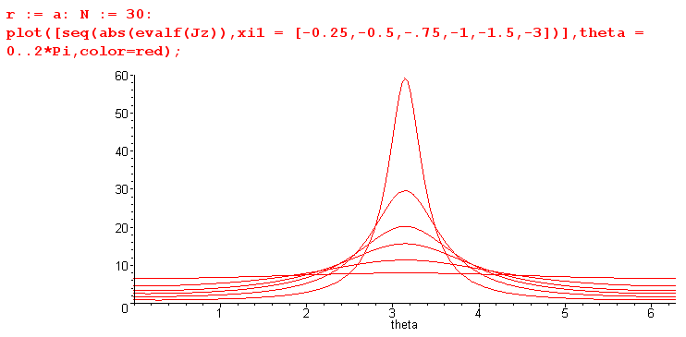
Fig 6.15

These plots of |Jz| bear a strong resemblance to the surface charge density plots shown above in Fig 6.9 for the same set of ξ1 values. It is shown in (D.10.15) that in the extreme skin effect regime we have

Jz(r,θ) = - (jω) (β/βd0) $\frac{a}{r}$e(1+j)(r-a)/δ n(θ) large ω (D.10.15) (6.5.13)

so we are not surprised to see that Jz(r,θ) tracks n(θ) in this manner. In the following section, we derive the above tracking relationship directly from div E = 0 .

