Bull by the Horns PhL 2.26.14

I reviewed this doc on 3/5/14, see red comments below. The Debye surface currents momentarily came back today and ruined the charge pump boundary condition, but then I made them go away again!

Did another review on 5/9/14, added some comments below on how the cpbc affects Jz . OK 5/12/14.

1. Essay on the subject of Asymmetry Correlation 2
2. Review of the Charge Pumping Condition: Debye Surface Currents ?? 4
3. Web on Debye Surface Currents ?? (find Pozar's book) 6
4. Levels of Approximation Idea. 8
5. What sections of lines doc are in trouble? 8

From "details of Chap 6 exact solution.doc" , here is some of the tangled web of issues that needs to be illuminated:
____________________________________________________________________________________
[ verbatim from above doc]

Status Report. I have multiple problems now that I think are all related, and they are big enough that I decided to pull my lines doc paper from the web for the time being until I can effect repairs. Here is a list of some of the problems:

(1) I have a logical failure [ Zs paradox ] in Chapter 4 as described in "details of Chap 6", and I suspect that the problem is either that W(z) on conductor cross sections is invalid, or that I need some approximation hierarchy for what to do after I do the low-loss analysis. [ the fix here is that W(z) will only be close to constant on the conductor boundaries in the strong skin effect regime, and so outside of that regime the King analysis and those classical transmission line equations don't really apply. ]

(2) If the B field lines are not tangent to the conductor surface, then I think W(z) cannot be constant on the surface, so this whole underpinning of lines doc wobbles. [ true, and for low ω the B field lines really are not tangent (see cyl plot), W(z) is not constant, and the theory does not work. ]

(3) This all ties in with the E • B = 0 problem which I did a half-baked rescue of. [ deferred // done ]

(4) I had the general feeling that the asymmetry of current in a conductor matched that asymmetry of the charge density on the surface and may have even stated as much in lines doc. I suspect that this association of the two asymmetries is only valid at "high frequency" where the skin effect is active. Probably at low frequency you could have a huge charge density asymmetry and a completely uniform Ez and Jz in the round wire or other conductor. [ I don't think this low frequency guess is right, but in the edge I hedge and say maybe that is correct and theory does not apply at low ω ]

(5) I am still unhappy about the question of "where does the surface charge come from"? I made that into a reader exercise because I could not answer it! [ deferred; but I think it comes from the radial charge pumping in all situations ]

So my current version of lines doc is then only a "working platform" which at least organizes certain pieces of EM information, but it is not ready for prime time because there are too many fudged and unanswered questions. I kept sweeping things under the rug to get it done, and now those things have come back to roost. But I do think I have the tools to approach the issues, and in the end I think I can get lines doc into something worth while. Right now it is worthless and embarrassing. In particular, I think I can compute a lot of things for the parallel cylinders based on the bipolar coordinates doc. [ agreed ]

[ As of 5/14/14 I think all these concerns are addressed and repairs have been made in lines doc. So it took about 10 weeks to get this all cleared up (one Cod trip. )]
____________________________________________________________________________________

Where do I start in this swirling dark cloud of confusion?

1. Essay on the subject of Asymmetry Correlation

Here I am really hunting around for a relationship between n(θ) and Jz(θ) just so I can connect the known asymmetry of n(θ) to the presumed asymmetry of Jz(θ). I am just probing around, flailingly.

What I really mean here is: how do you connect the Er(a+ε)- Er(a-ε) surface charge activity (especially its asymmetry) with the current-causing Ez(a-ε)? I have never understood this really. One dim idea was that there is Er(a-ε) "radial charge pumping" to the surface and maybe that is connected with Ez(a-ε), but I was never really convinced of that idea, though I quote it many times.
Just below the conductor surface, and everywhere inside the conductor, there is no free charge, I have at least established that fact. Therefore, div J = 0 in there, where J is conduction current, and I am using the result (1.1.25) that div Jc = -∂tρfree = -jωρfree = 0. So certainly this is one relation between aspects of the currents. In cylindricals this says

div J = r-1∂r(rJr) + r-1∂θJθ + ∂zJz = 0
div E = r-1∂r(rEr) + r-1∂θEθ + ∂zEz = 0 (*)

Right off the bat we are then involved with the cat o' nine tails ∂θJθ, an endless scourge for me. Is there or is there not "azimuthal action" in a transmission line? My "solution" for the round wire suggests that you cannot avoid having some Jθ action just because it is tied in with everything else. Recall

First summary of the E field solutions (D.2.21)

Ez(r,m) = - j (β'/βd) $\frac{Km}{2}$ Jm(x) x = β'r (D.1.27)

Er(r,m) = am x-1 Jm(x) + $\frac{Km}{2}$ Jm+1(x) β'2 = β2 - βd2 (D.2.11)

jEφ(r,m) = - am x-1 Jm(x) + ( $\frac{Km}{2}$+ $\frac{am}{m}$ ) Jm+1(x) (D.2.15)

Ignoring the boundary conditions (which maybe are wrong), this general FORM of the solution I think is correct, and you see Eθ(r,m) sitting there. To kill it off completely requires am = Km = 0, and that then kills off everything! So we really are stuck with azimuthal swirling currents. [ OK, yes, Eθ(r,m) exists ]
Now I can at least write div E = 0 in partial waves as in (D.1.19),

∂r [r Er(r,m)] + jmEφ(r,m) -jβd r Ez(r,m) = 0

where now there is only a radial derivative to complicate things. This equation really does tie the three field components together somewhat! Then of course I have the three Helmholtz component equations as well, so all four are shown in box (D.1.20) where maybe only 3 of 4 are independent.
I have written things in cyl coords since I wanted to treat the round wire, but I still am convinced you can do this for arbitrary cross section wire I first starting thinking this with Fig 3.3

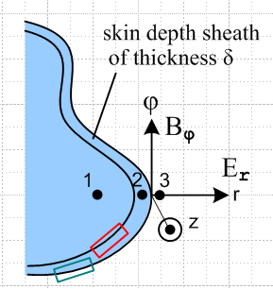

where I have a LOCAL cyl coord system right at the surface. The idea is that locally the surface has the shape of a round wire. I make this more explicit in Fig B.6

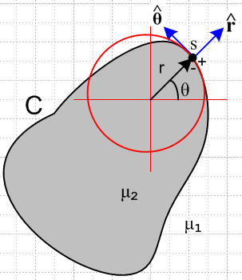

where here we match the boundary curvature by placing the cyl coord axis in an appropriate position. This is really the better picture I think. Your results then will be "accurate" not just at one point, but in the neighborhood of that point.
So the hope here is that you can use cyl coords for a non-round wire and then all four of those equations are at least "meaningful":

The Three Helmholtz Equations and the div E = 0 equation (in partial waves) (D.1.20)

[∇2E]z + β2 Ez = 0 :
[r2∂r2 + r ∂r - m2 + r2 ( β2- βd2)] Ez(r,m) = 0 (D.1.15)

[∇2E]r + β2 Er = 0 :
[r2∂r2 + r∂r - (m2+1) + r2(β2-βd2)] Er(r,m) - 2jm Eφ(r,m) = 0 (D.1.17)

[∇2E]φ + β2 Eφ = 0 :
[r2∂r2 + r∂r - (m2+1) + r2(β2-βd2)] Eφ(r,m) + 2jmEr(r,m) = 0 (D.1.18)

div E = 0 :
∂r [r Er(r,m)] + jmEφ(r,m) -jβd r Ez(r,m) = 0 (D.1.19)

That is to say, these equations in cyl coords apply to any cyl coord system you want, any z axis you want, such as the one shown in the last figure above. If the wire surface is flat, perhaps Cartesian coordinates work better. We would then have no PWA and then simply,

(∂x2 + ∂y2 + ( β2- βd2))Ex(x,y) + β2 Ex(x,y) = 0
(∂x2 + ∂y2 + ( β2- βd2))Ey(x,y) + β2 Ey(x,y) = 0
(∂x2 + ∂y2 + ( β2- βd2))Ez(x,y) + β2 Ez(x,y) = 0
∂x Ex(x,y) + ∂y Ey(x,y) -jβd Ez(x,y) = 0

The three field components are still entangled by the last line, but the Helm's are isolated. In either coordinate system, we have something like this going on from div E = 0:

div2D E2D = jβd Ez

This says that, although there is no free charge, from a 2D viewpoint there IS some charge due to the non-zero ∂zEz. Variation in Ez creates 2D charge for the right side of this equation. Think ∂zJz. If you make a 2D Gaussian box, then you get inflow or outflow through the transverse walls if there is a ∂zJz.

[ Note added 5//9/14. The div E = 0 Argument for why n(θ) determines Jz asymmetry:

Consider (D.1.19) above for r just below the surface:

∂r [r Er(r,m)] + jmEφ(r,m) -jβd r Ez(r,m) = 0 (D.1.19)

Since Eφ(r,m) = 0 right at the surface, it is small just below the surface, so neglect it to get

∂r [r Er(r,m)] -jβd r Ez(r,m) = 0 r = a-ε

We then have a direct connection between Er and Ez , which means a direct connection between Jr and Jz, the thing I am looking for. The radial charge pump condition involves Jr and the above equation then ties that to Jz. The cpbc states that

Er(r=a,m) = (jω/σ) Nm . (D.2.25)

Then a certain pattern of Nm coefficients (a certain n(θ)) implies a certain form for Er(r,m) at and therefore below the surface, and this in term determines ∂r [r Er(r,m)] and that in turn determines Ez(r,m).
Let's now repeat this argument in regular θ space. We start with

∂r (r Er(r,θ)) + ∂θEθ(r,θ) + r ∂zEz(r,θ) = 0 div E = 0 just below surface.

We argue that just below the surface, ∂θEθ(r,θ) = 0 because Eθ(a,θ) is constant at the surface in θ. Then we have

∂r (r Er(r,θ)) + r ∂zEz(r,θ) ≈ 0
or
∂r (r Er(r,θ)) - r jβdEz(r,θ) ≈ 0 . (*)

The cpbc states that

Er(r=a-ε,θ) = (jω/σ) n(θ)

Then a certain form for n(θ) implies a certain form for Er(r,θ) at and therefore below the surface, and this in turn determines ∂r (r Er(r,θ)) which then determines Ez(r,θ) using (*). ]

2. Review of the Charge Pumping Condition: Debye Surface Currents ??

Disaster strikes: Here I think I have to worry about surface currents in my charge pumping condition which makes a mess of Appendix D's constants an and Kn. Such currents would also mean Ht was no longer continuous at the surface. But in "continuity at conductor surface" I think I successfully argued just now (3/5/14) that in fact the surface currents really play no role in the pumping boundary condition!

Pause. I am now looking at my (D.2.23) "charge pumping condition" and the picture leading up to it. Here is the text:

The reason we are interested in the surface charge n(φ) of (D.1.5) is that it acts as a driving source of the radial electric field in the wire. Recall the equation of continuity (1.1.35) converted to the ω domain

div J = - jωρ ⇔ -jω[∫V ρ dV] = ∫S J • dS . (D.2.22)

This is meant to be (1.1.25) where J is conduction current and ρ is free charge. When applied to a thin box of radial area dS straddling the wire surface,

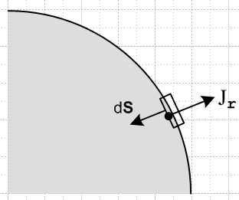 Fig D.2

one finds that ∫S J • dS = -Jr(r=a-ε,φ)dS and ∫V ρ dV = n(φ) dS so that (ε implies just below surface)

Jr(r=a-ε,φ) = jω n(φ) . (D.2.23)

But suppose there are free surface charges moving on the conductor surface. [ here is where I first worry about this possibility.] In that case, I think you really do have "surface currents" of the Kz and Kφ variety, and these are "singular", and then the above condition is invalid!!! So this is a huge underpinning beam of my structure that looks wrong.
For a round wire, the above condition should be replaced with this:

dAz = rdθdr Jz dAz = Jz rdθdr = Kzδ(r-a) rdθdr = Kzδ(r-a) adθdr

[Kz(z+dz) - K(z)] rdθdr = contribution to ∫S J • dS of these two box sides

= Kzδ(r-a) adθdr → Kz adθ

Then the top and bottom sides have

dAθ = dz dr JθdAθ = Jθ dz dr = Kθ δ(r-a) dz dr

[Kθ (θ+dθ) - K(θ)] dz dr = contribution to ∫S J • dS of these two box sides

= (∂θKθ)dθ dz

Then the radial sides of the box, if no conducting dielectric, give

dAr = -dz rdθ JrdAr = -Jr(a-ε)dz rdθ

Then the corrected continuity condition is this:

-jω[∫V ρ dV] = ∫S J • dS

-jωn(θ)adθdz = -Jr(a-ε) dz rdθ + (∂zKz)dz adθ + (∂θKθ)dθ dz

-jωn(θ)a = -Jr(a-ε)a + (∂zKz)a + (∂θKθ)

Later I will redo this all correctly, but here is the Main Point.

Discovery: I have completely omitted two current variables in my analysis, the surface currents Kz and Kθ as illustrated here. These exist, but I have in effect set them to zero which is completely wrong. This then helps explain my "reader exercise" confusion about "where do the charges come from". This is a very major change in my view of things! I suppose in the partial wave analysis we could say

-jω a n(m) = -Jr(a-ε,m)a -jβd a Kz(m) + jmKθ(m)

What else do I know about the surface currents Kz and Kθ ?? Recall from box (1.1.50),

Ht2 - Ht1 = Kzfree or (1/μ2)Bt2 - (1/μ1)Bt1 = Kzfree (1.1.44)

Special case A = Az(y,z) : (1/μ2) (∂nAz)2 - (1/μ1) (∂nAz)1 = Kzfree (1.1.46)

So the tangential component of the H field is no longer continuous even if μ = same everywhere. And we have new issues with the Az boundary condition! Argghhhh! This has massive implications.

How is Kz related to Ez at the surface? This is another "swept under the rug" issue. Jz = σEz away from a surface. Is there some surface conductivity so Kz = σsurf Ez , yet another parameter to worry about??

3. Web on Debye Surface Currents ?? (find Pozar's book)

I guess I searched on "surface currents" and I then discovered Pozar's microwave book which I later reviewed pretty well. But I think all these Pozar surface currents are really skin depth currents and not Debye currents, so I learned nothing about Debye surface currents.

I wander out on the web:

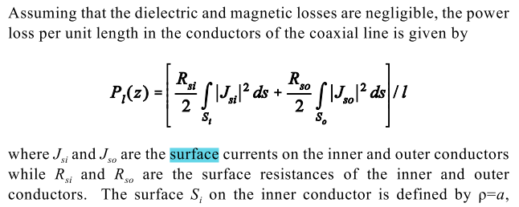

www.ece.msstate.edu/.../ece4333notes2.pdf‎

Then they say,

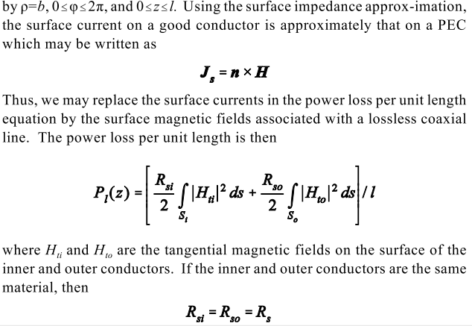

But the thing PEC is never defined in this document! But this author has a nice set of microwave notes, and they are here,

http://www.ece.msstate.edu/~donohoe/ece4333.html

Course Textbook - David M. Pozar, Microwave Engineering, 3rd. Ed., John Wiley & Sons, 2005, ISBN 0-471-44878-8

His notes are perhaps the best I have seen. I am looking for the textbook now. // I have it, and it definitely has good stuff in it.
The entire book never mentions "vector potential". So this is a completely non-King approach to transmission lines! It is entirely "fields based". Perhaps that is the right way to go.

They both like to say that the surface current is Ks = Ht. I say in (1.1.44) that

Ht2 - Ht1 = Kzfree

I had the idea that Ht was about the same inside as outside, but they are saying Ht = 0 inside because E = 0 inside. Ouch! Another basement beam creaks. For a magnetostatic wire, Ht really is the same inside and outside, but you would never say Ks = Ht. There is no surface current in that case.

4. Levels of Approximation Idea.

So perhaps this has to do with the "levels of approximation".

At the zeroth level, E = 0 identically inside a transmission line conductor, We know this cannot really be true since there is a current in there, but OK, σ is very large, so despite J, we have E = 0. Then Maxwell says curl E(x,ω) = -jωB(x,ω) and so in this level of approximation, you have B = 0 everywhere inside as well! At this level then you really do have Ks = Ht(a+ε). At this zeroth level, we are able to compute things like E and B outside the conductors, and surface charge on them.

At the first level, correction to the above, you have E ≠ 0 inside a conductor. My entire Chapter 2 and entire Appendix D is at this level, where σ = finite, and we talk about E and B fields inside a round wire. Presumably compared with the E and B fields outside the wire, these internal fields are all very small. If that is the case, then Ks = Ht(a+ε) is still approximately true. But at very low frequency I know that in fact Ht(a+ε) ≈ Ht(a-ε), so this Ks = Ht(a+ε) cannot be true. Look again at curl E(x,ω) = -jωB(x,ω) . In the zeroth level approximation, I want to set E = 0 and B = 0 inside. But in fact, as ω → 0, LHS = 0 and the RHS = ω * B = 0 * B so B can be "anything", and it is NOT zero in mag statics. So we have a sort of matrix here. One dimension of the matrix is something like this

very low frequency E ≈ 0 but B ≠ 0
low frequency no skin effect
high frequency skin effect
very high frequency violate transmission line limit.

The other dimension is

perfect conductors σ = ∞ E = 0 and B = 0 inside ω > 0
lossy conductors σ = finite E ≠ 0 inside, B≠ 0 inside, but both are small.

5. What sections of lines doc are in trouble?

Lets stop for a while and look at which parts of lines doc are still OK (trouble refers to things like W(z) not constant on conductor boundaries)

Chap 1 whole chapter is OK I think.
Chap 2 round wire fields inside, all OK
Chap 3 OK up to Section 3.5 where I do the qualitative stuff on field sizes
rest of this chapter is dubious!
Chap 4 not sure where this stands. It is all potential-based. Certainly there are problems
Chap 5 Probably the potential φ part is OK, not so sure about the Az part.
Capacitor problem is OK. Loss part is marginal.
Chap 6 is all OK I think.
App A on gauge, probably all OK
App B. Well now there are mag and regular surface currents ! This is in trouble.
App C: DC inductance of things, probably OK
App D: Fields in round wire, OK except for the boundary conditions!!
App E: How thick is σ OK
App F: waveguides, OK for quickie
App H and I and K both OK, propagators
App K on network model OK
App L OK on dielectric toy problems.

I have marked in red the parts of lines doc that are in trouble.

// I have now browsed through the huge Pozar book. It was very interesting, but does not have any silver bullets to solve my confusions.

I will stop here and start a separate doc to ponder the surface currents.

