The Surface Currents Issue PhL 2.27.14

A long rambling document, sort of pursuing "issues" as they come up, stream of consciousness.

Summary: [ final review 5.14.14 is all OK ]

I start off Section 1 wondering about the Debye surface currents and why no one talks about them, but later in Section 7 I argue that you can always ignore Debye surface currents (though not the surface charge). Note that Sections 1, 7 and 10 are all on Debye currents!
In Section 2 I have forgotten the skin effect and am surprised that H = 0 inside a "perfect" conductor.
In Section 3 I show that H in a wire does not change from ω = 0 to ω = low frequency, but what does change is that Er develops a tiny incipient skin effect to make curl E = -jωB continue to be valid, which one can write as ∂rEz(r) = -jωBθ = -jωμHθ = -jωμ(1/2π) (r/a2).
In Section 4 I worry about whether there is no traveling wave solution at low ω, but I'm sure there is, but perhaps it is not described by the "transmission line equations", I have not resolved that yet (3/5/14). // I think as of 5.14.14 that I would say low ω does NOT follow those equations very closely!
In Section 5 I do the curl for bipolar cylinder coords and confirm curl E = 0 for electrostatics!
In Section 6 I write exact Hx and Hy expressions for two cylinders with uniform Jz, later to plot with. This is important stuff, don't lose track of it! *********
In Section 7 I argue that the Debye surface current is just part of the bulk surface volume current.
In Section 8 I argue that surface charge really does come from Jr radial pumping, and not from some kind of Debye currents on the surface. This section considers many ways of looking at surface current.
Section 9 brings up a quick paradox of the two adjacent rings, then resolves that paradox on the spot. I just added this little idea to my "voltmeter voltage" idea (3.8.7) of lines doc, 5.14.14 . // But then I removed it again because I don't really know whether a voltmeter reads Δφ or line integral of E, and the meter lead induced EMF further confuses things!
In Section 10 the charge pump boundary condition meets and survives another challenge from the Debye currents.

1. Web search on notion of Debye surface currents. 1
2. Why is H = 0 inside a perfect conductor? 4
3. The finite H field inside a real wire. 4
4. Is there really a wave solution at low ω ? 6
5. Compute curl E for the bipolar doc solution in bipolar coordinates 7
6. Computation of the H fields for the two-cylinder problem with uniform currents 9
(a) Computation outside the conductors only 9
(b) Redo the computation so valid both inside and outside cylinders 11
7. Comments on Debye surface currents (from bed session) 13
8. Comments on "Where does the surface charge come from, and where does it go? " 14
9. The two rings paradox and its resolution 15
10. More on Debye Surface Currents ( 3/17/14) 16

1. Web search on notion of Debye surface currents.

I would first like to find some other source that talks about surface currents in the sense that I mean. I don't want to go completely alone on this subject!

"surface currents" "transmission line"

"surface current" "Debye length" copper

I am getting very little. Here is one comment:

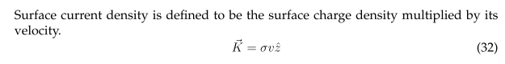
This seems reasonable, but what kind of current would an electric field then produce?
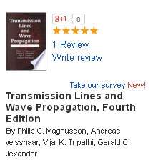

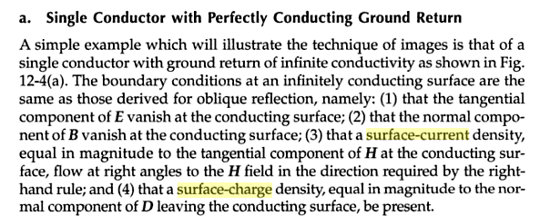

OK, here we have several statements of interest.

(1) Bn = 0 at the surface. Why is this so? I recall quoting it in my waveguide appendix.
(2) says there is Ks = Ht. This must mean that Ht = 0 inside the metal. Why is this so?

[ Answers: (1) Bn = 0 at the surface because Bn = 0 just below the surface inside due to skin depth, as I now point out in (3.7.17). (2) Ht = 0 inside for exactly the same reason, skin effect. Notice that the authors use the phrase "infinitely conducting surface" instead of "extreme skin regime". ]

In that oblique section same authors say

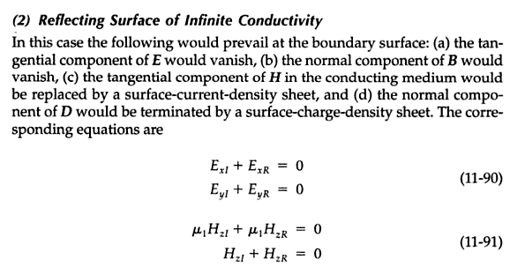
So my questions are not answered.

2. Why is H = 0 inside a perfect conductor?

This is the sort of the thing I am confused about. We know that

curl E = -∂tB

If E ≡ 0, then B = constant in time.

So, if we have current I in a round conductor, yes we have B inside, but it is a constant B.

Suppose we replace the DC current I with a 1 Hz time-varying current, and it runs through a perfect conducting wire. Then what happens? E = 0 inside still. We must have ∂tB = 0. Again, B must be a constant, but what would that constant be? I think it has to be 0.

So we have a very dramatic transition between ω = 0 and ω = .00001 Hz ? A new paradox.

Experiment #1. Transmission line with two 1 foot diameter solid perfect conductors. AC source has period of 24 hours. I come along at some time and measure the magnetic field inside one of the conductors. Is it 0, or is it determined by 2πr H = π(r2/a2)I ?

Right now this is a nubbins question (nub of the matter) for me! I would vote for not H ≠0. [ correct ]

Argument for H=0: We know curl E = - ∂tB is true. Write as curl E = - jωB . If it is really true that E = 0 (after all, σ = ∞, perfect conductor), then even if ω = 10-8, we have B = 108 curl E = 0. But if ω = 0 exactly, then suddenly curl E = - jωB says nothing at all about B in terms of E.

Well, suppose we turn on some finite σ and then we have some finite Ez and assume Er = Eφ = 0. Then

curl E = [ r-1∂θEz - ∂zEθ] + [∂zEr - ∂rEz] + [ r-1∂r(rEθ) - r-1∂θEr ]

curl E = [ r-1∂θEz] + [∂rEz]

Well, if Ez = constant on the inside of the round wire (uniform), then what? Then curl E = 0 ! So turning on an Ez field inside the round wire is not enough to create H inside! We still have curl E = 0 and then B = 0 at any non-zero frequency. The B field comes from ∂rEz which is that skin effect thing! [ ok ]

3. The finite H field inside a real wire.

1. If the wire is "perfect" with σ = ∞, then E = 0 inside exactly, and curl E = -jωB says that B = 0 inside, it is really true. This is the Meissner effect for superconductors, the B field is "expelled" even at 10-8 Hz.

2. If the wire is an excellent conductor like copper but has finite σ, then things are different! Now we can no longer claim that E = 0 inside the conductor. As I well know, the dominant field inside a transmission line conductor is the Ez field due to the longitudinal current in the wire. At a very low ω, we have curl E = -jωB and we intuitively know that B is going to be roughly the same as it is at DC. For a round wire with azisym, solution of that problem arises from the curl H equation and we get 2πrHθ = (r2/a2) I from the curl H equation.

Note added 3/5/14: This calculation is from Ampere's Law based on curl H = ∂tD + J. In lines (3.4.1) I show that in a good conductor like copper, you can always ignore the displacement current term jωεE compared to the conduction current term J = σE at least up to 109 GHz. Thus, when we "turn on the AC" by bringing ω > 0 from DC, our Ampere's Law result 2πrHθ = (r2/a2) does not change!

So how does this jibe with the curl E equation? Assuming the current is axially symmetric, we have curl E = -(∂rEz) [ since ∂θEz = 0 ]. Thus, we have -jωB = -(∂rEz) which says B = [-(∂rEz)/(jω)] . At very low ω, we could solve this to get

∂rEz(r) = -jωBθ = -jωμHθ = -jωμ(1/2π) (r/a2)

Ez(r)-Ez(0) = -jωμ(1/2π)(1/a2) $^{\int_{0}^{r}{}}$dr r = -jωμ(1/4π)(r2/a2)

This says that Ez(r) varies with r slightly, even at ω = 10-8, and this is the "incipient skin effect". You can hardly see it when ω = 10-8. [ correct . This scenario would apply to wide-spaced twin lead. ]

3. As ω increases, the skin effect increases and fields are pushed out toward the conductor surface.

4. Recall that δ = $\sqrt{2/μωσ}$. If you are at any fixed frequency ω, as the conductor becomes "perfect", then δ → 0 and there is your field exclusion. Perfection comes either from ω or σ → ∞.

5. If you are operating in the strong skin effect regime (say δ < a/10), then current is in a thin δ layer, and Ht = 0 on the inside and Ht = finite on the outside, and you get something like K = Ht for a "surface current" which really means the entire skin effect surface current, nothing about Debye thickness here!!!

6. What about Hn for Perfect Conductor? I guess we can say

curl E • = -jωB • = -jωBn

In the perfect conductor since E ≡ 0, we have Bn = 0 right out to the conductor surface. Then Bn = 0 just outside as well, and we have our Hn = 0 at the surface "fact". [ correct ]

7. For copper as conductor, we have -jωBn = curl E • ≈ -(∂rEz) • = 0 (for the azisym round wire) ! There it is! Even though we have some non-vanishing E field now, if that E field is all Ez and isotropic around the round wire axis, then you still have Bn = 0 everywhere inside, and then this is true also at the surface! This fact is independent of frequency and is unrelated to the skin depth δ.

8. Perhaps this Bn = 0 becomes violated when we allow Er and Eθ fields to exist inside the wire. But in general they are much smaller than the already small Ez !!

9. Now go back to the Purcell DC H field picture where Hn ≠ 0 for a non-round weird conductor cross section. Let's even take my rectangular conductor of Appendix C where we know Hn ≠ 0 everywhere on the perimeter at ω = 0. We still have the equation -jωBn = curl E • . But now

curl E = (∂yEz - ∂zEy) + (∂zEx - ∂xEz) + (∂xEy - ∂yEx)

Assuming again that the main current is Ez, this says

curl E = (∂yEz) + (- ∂xEz)

Then

curl E • = nx(∂yEz) + ny(- ∂xEz) = -jωBn

For ω ≠ 0, we know that at least one of these derivatives is non-zero due to the incipient skin effect (whichever direction heads toward the interior of the conductor will have non zero derivative). And so it is that for ω ≠ 0 we can maintain our DC B field shape, AND we can have Bn and Hn ≠ 0 at the surface.
So the Hn = 0 argument of item 7 above is specific to the round wire with azisym current.

10. In the strong skin effect limit, there is an argument that Hn = 0, but I have not yet nailed it down. I think the idea is based on this

div B = 0 ⇔ ∫S B • dS = 0 S is any closed surface (1.1.34)

If you are in the strong skin effect limit, then you can draw a THIN Gaussian box around the current, and perhaps you can sort of ignore the sides of the box. Moreover, for the two sides exposed to Ht, you get the same cancelling contributions. You then have Hn1 = Hn2 on the two sides of the current layer, but Hn1 = 0 on the inside from field exclusion, so then Hn = 0 at the surface. Only in the skin effect limit!! And I might set this limit to δ = a/10 or some such to get ballpark estimates for when you start getting Hn = 0!
[ see "the current asymmetry" item 8 for more on this ]

Done for today.

2/28/14 Continue

4. Is there really a wave solution at low ω ?

OK, suppose we have a transmission line far away from the skin effect limit, low frequency. The discussion above suggests that we still have the electrostatics En = 0 at conductor surface, but we do NOT have Bn = 0 there. So we do not have E•B = 0 just above the surface. Is this still a transmission line with a wave going down it? Do we still have a Maxwell equations solution? I have always assumed that a wave solution exists all the way down to ω = 0.

Well, I suppose that if you drive such a transmission line with AC voltage V at some low ω, a wave does go down the line as usual and it has some Z0 and this wave then has E•B ≠ 0 at the surfaces. But to really know this, we have to show that the "transmission line equations" are valid in this case, and I don't think I know how to show that because of my Az = constant on surface problem, so maybe I need to go examine that issue next.

Eventually at low ω I want to find out "what pushes the surface charge around and how does it move?"

5. Compute curl E for the bipolar doc solution in bipolar coordinates

Looking at bipolar doc, I find this for the E field between the round conductors,

E = -gradφ = (V/h) $\frac{1}{ξ2-ξ1}$

Now I would like to use the curl E equation

curl E = - ∂tB = -jωB

so I might now compute the curl in what M&S call "bi-cylindrical coordinates" which would be appropriate for the transmission line. This is something I skipped over in bipolar and I should probably add it.

[ Note: Since bipolar doc does an electrostatics problem, don't be surprised if you find that curl E = 0. In this case the above says at finite ω that B = 0, really B = constant ]

curl orthogonal:
[curl B](x) = (h1h2h3)-1 B = Bnn // M&S 1.07a

Let 1,2,3 = ξ,u,z. Perhaps first compute the metric tensor in this system. I just added this to metric tensor.mws in bipolar folder and got hz = 1 as expected so the above becomes

[curl B](x) = (h2)-1 B = Bnn // M&S 1.07a

h2[curl B](x) = h = a/(chξ–cosu)

= hξ [ ∂uBz - ∂z(hBu) ] - hu [ ∂ξBz - ∂z(hBξ) ] + [∂ξ(hBu)- ∂u(hBξ) ]

Therefore

h2[curl E](x) = hξ [ ∂uEz - ∂z(hEu) ] - hu [ ∂ξEz - ∂z(hEξ) ] + [∂ξ(hEu) - ∂u(hEξ) ]

But for our example, we have

E = -gradφ = (V/h) $\frac{1}{ξ2-ξ1}$ = Eξ Eξ = (V/h) $\frac{1}{ξ2-ξ1}$

so the result simplifies,

h2[curl E](x) = - hu [- ∂z(hEξ) ] + [- ∂u(hEξ) ]

= h ∂z(hEξ) u - ∂u(hEξ)
where
hEξ = V $\frac{1}{ξ2-ξ1}$ = a constant!

Thus things simplify to

h2[curl E](x) = h ∂z(hEξ) u - ∂u(hEξ) = 0 [ surprise! ]

Oops, what happened here? In bipolar I solved the capacitor problem only,

∇2φ(x,y) = 0 => ∇22D φ(x,y) = 0 ∇2 = ∇2D2 + ∂z2 . (10.1)

I have to look at lines doc Section 5 on the transverse problem. I think these equations are OK

[ ∂z2 + kφ2 ] q(z) = 0 (5.1.8)

φ(x,y,z) = $\frac{1}{4πξ}$ q(z) φt(x,y) (5.1.1)

[ ∂z2 + kφ2 ] φ(x,y,z) = 0

[ ∂z2 + kφ2 ] V(z) = 0 // V(z) = φ(x1) - φ(x2)

But I cannot go further without facing the i(z) part of the problem. All I have shown above is that in a pure electrostatics problem with no currents, indeed curl E = 0. [correct] So at least it was good to verify this fact using bipolar coordinates. [ yup ]

Conclusion: Bipolar coordinates won't help me plot the B field at low frequency for two round wires, in the sense that I wanted to use the equation -jωB = curl E to find B.

6. Computation of the H fields for the two-cylinder problem with uniform currents

The two contributing pieces don't point along bipolar coordinate lines [ but eventually we shall see that the B sum does point along the bipolar coordinate lines, outside the conductors! ] . So I have to manually solve this problem and then maybe compare with a result I found in a book. 1 2 θ1 θ2

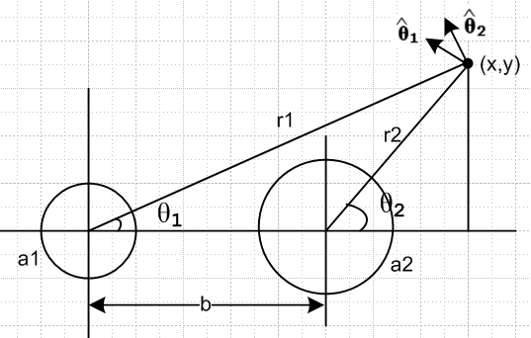

1 = -sinθ1 + cosθ1

2 = -sinθ2 + cosθ2

(a) Computation outside the conductors only

Now around a round wire with uniform current we have

2πrH = I H = I/2πr

Thus

H1(r1) = I/2πr1
H2(r2) = -I/2πr2 // opposite directed current - I on the right

Then

H = H1(r1) 1 + H2(r2) 2

= I/2πr1 [-sinθ1 + cosθ1] - I/2πr2 [-sinθ2 + cosθ2]

= (I/2π) { [-sinθ1/r1 + sinθ2/r2] + [cosθ1/r1 - cosθ2/r2]

where:

cosθ1 = x/r1 sinθ1 = y/r1

cosθ2 = (x-b)/r2 sinθ2 = y/r2

So then

H = (I/2π) { [-sinθ1/r1 + sinθ2/r2] + [cosθ1/r1 - cosθ2/r2]

= (I/2π) { [-y/r12 +y/r22] + [x/r12 -(x-b)/r22]

r12 = x2 + y2 r22 = (x-b)2 + y2

So here is the result

Hx = (I/2π) [-y/(x2 + y2) +y/(x-b)2 + y2)] = (I/2π)y[-1/( x2 + y2) + 1/(x-b)2 + y2)]

Hy = (I/2π) [x/( x2 + y2) -(x-b)/( (x-b)2 + y2)]

Once again

Hx = (I/2π)[ -$\frac{y}{x2+y2}$ + $\frac{y}{(x-b)2+y2}$]

Hy = (I/2π) [ $\frac{x}{x2+y2}$ -$\frac{(x-b)}{(x-b)2+y2}$]

As expected, the result is independent of a1 and a2 and would apply to the case of two thin wires.

Time for some Maple work! It gives the following field plot:

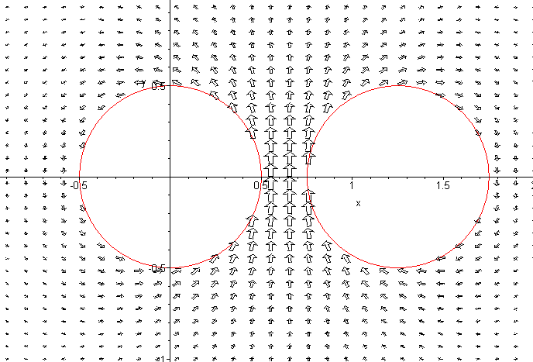

(b) Redo the computation so valid both inside and outside cylinders

But what I really need are the field lines! You cannot get a clean view with a field plot. But the field plot shows that things are reasonable, probably my expressions and all signs are OK.
In order to do a field-lines plot, I need to include the insides of the circles !! So

H1(r1) = (I/2π)(1/r1) for r1 > a1
H1(r1) = (I/2π)(r1/a12) for r1 < a1

H1(r1) = θ(r1>a1) (I/2π)(1/r1) + θ(a1>r1) (I/2π) (r1/a12)
= (I/2π)[ θ(r1>a1) (1/r1) + θ(a1>r1) (r1/a12)]

So then

H1(r1) = (I/2π)[ θ(r1>a1) (1/r1) + θ(a1>r1) (r1/a12)]
H2(r2) = -(I/2π)[ θ(r2>a2) (1/r2) + θ(a2>r2) (r2/a22)]

H = H1(r1) 1 + H2(r2) 2

1 = -sinθ1 + cosθ1
2 = -sinθ2 + cosθ2

H = H1(r1) [-sinθ1 + cosθ1] + H2(r2)[ -sinθ2 + cosθ2]

= [ - sinθ1H1(r1) - sinθ2 H2(r2)] + [cosθ1 H1(r1) + cosθ2 H2(r2)]

cosθ1 = (x/r1) sinθ1 = (y/r1)
cosθ2 = ((x-b)/r2) sinθ2 = (y/r2)

H = [ - (y/r1)H1(r1) - (y/r2) H2(r2)] + [(x/r1) H1(r1) + ((x-b)/r2) H2(r2)]

Hx = - (y/r1)H1(r1) - (y/r2) H2(r2)
Hy = (x/r1) H1(r1) + ((x-b)/r2) H2(r2)

I did this and did a new field plot,

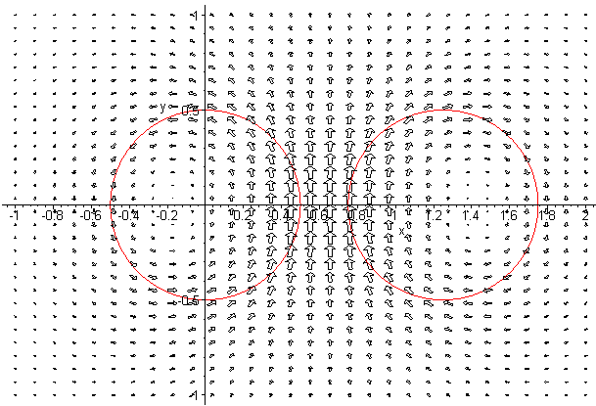

and things seem very reasonable. And B fields are not tangent to circles I would say! I did my usual slow line plotter and got this as my best result (5 min run time with ds = .002)

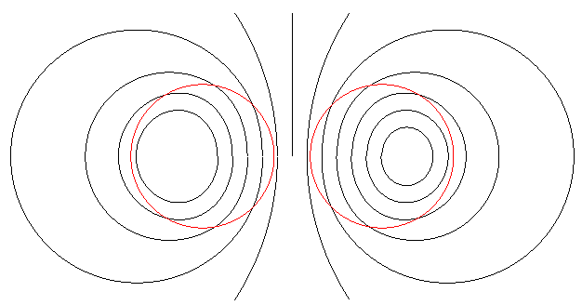

Observations: [ all correct ]

• This plot shows H field both inside and outside the conductors using correct formulas and superposition.
• The curve shapes are rather strange, especially on the inside,
• The H field is NOT tangent to the conductor surface, there are Hn components everywhere.
• This would be the H field shape for a low-frequency transmission line!
• Assuming E is normal to the surfaces, we have E • B ≠ 0 on these surfaces.
• The fact that curves loop back onto themselves confirms accuracy of method
• These contours are the contours of constant Az12 !!
• The conductor surfaces are NOT surfaces of constant Az12, so the W(z) thing fails.

7. Comments on Debye surface currents (from bed session)

1. Since there is always conduction current inside a transmission line conductor just below the surface, you can perhaps think of the Debye-depth surface current as just a part of this conduction current. To the extent that we model the Debye situation as volume of a small depth at the surface, it is really just part of the conduction current! It feels the same Ez driving force. The fact that there is a diffusion repulsing force at the surface does not affect this Debye current.

2. Secondly, if δ = 4000δdebye, then the Debye current can be completely neglected compared to the skin effect current, and also with the general bulk current at low frequency. This is just because the area that the Debye current flows through (2πa δdebye) is minuscule compared to the skin effect area or the full cross section area where everyone sees the same Ez. So this in itself is a good argument saying you can neglect the Debye current (which is in the same z direction pushed by Ez as the bulk current). So I don't see a need to have a new variable Kz,debye floating around in the analysis! [ all correct! ]

3. This same comment would apply to any θ component of Debye current, if it ever were to exist. It is always swamped by the θ current inside the wire.

4. Therefore: It is true that the surface charge (the Debye charge if you will) exists on the surface, and it is true that it moves (or can move) in z and θ directions on the surface, and it is true that such movement results in Debye surface currents. But we can always completely ignore these Debye currents since they are completely swamped by nearby volume currents. And in fact the Debye current is just a tiny surface part of that large volume current.

So this at least gives me a resolution to one "big problem" I was concerned with. It probably explains why no one on the web seems concerned with Debye surface currents. [ but it is an interesting question ]

8. Comments on "Where does the surface charge come from, and where does it go? "

1. It is true that the surface charge pattern moves down the z axis at some large fraction of the speed of light. If we sit at some z = z1 and watch as the waves go by, we see surface charge n(θ) becomes positive all around the conductor, then a half period of time later we see if to negative all around. If we look at some particular surface patch dS with is dq = ndS, we see this charge physically change in time.

2. So there is a fair question: lets say the charge dq at some time instant is "going more negative". It is a fair question to ask: where are the extra electrons coming from to make dq be more negative?

3. [ this item not convincing] To investigate this question, suppose we put a dime-shaped gaussian box straddling the conductor boundary, which box has tiny area dS and we apply ∫S J•dS = -∂t(dq) . This box does have thin "sides" to think about, along with the main "large sides" which have area dS. The four thin sides could in theory feel the effect of the Debye surface currents in both θ and z directions. So in theory dq would be effected by the current flowing in or out through these four thin surfaces. Let's represent these by volume currents Jz and Jθ. Although these might not be zero, they are not infinite. In fact the Debye current does have a δdebye thickness in our model, so as this box is made very thin, we can truly ignore the four thin sides. Even if we could not, we would argue that the box is so tiny that each pair of sides cancels.
Now what about the fat surfaces. The most dramatic situation arises when the dielectric has no σeff and in this case we find from continuity simply that

∫S J•dS = -∂t(dq) => -JrdS = -∂t(ndS) Jr = -∂tn

This then provides an answer to the question asked in item 2 above: Although it seems that some of the surface charge could come from the Debye surface currents, in reality the charge comes from the radial internal current in the wire. So this seems to validate my long-claimed "surface charge pumping" idea.

4. Consider then the surface charge pattern running down the wire at half the speed of light. You could perhaps imagine some "parallel universe" where there was actual charge running down the conductor at half the speed of light! That would be a possible explanation of what one is seeing. Those electrons are actually going at half the speed of light! But in our universe, we know that electrons go a few mm per second (I have numbers somewhere). So we discard the "relativistic electrons theory" !

5. Another theory is the "ten little Indians" theory. This is the way bulk current flows in a wire. You have 1015 slow electrons flow 1 mm into one end of a wire, and 1015 different electrons flow out the far end at the same time, and that is your 10 amperes or whatever. This same "ten little Indians" theory can be applied to the surface current in the z direction. In fact, I think that is exactly how the surface current "moves" along the surface. But, in terms of our little gaussian box, the same amount of surface current flows in one side as flows out the other side, so n in the box is not affected. I guess there is a slight variation in that surface current with z according to the wavelength.
Well, if we allow Jz to vary we can examine the z-pair of thin box faces and find that

∂zJz = -∂tρ n = ρ δdebye

∂zJz = -∂tn (1/δdebye)

So here the non-uniform-in-z Debye surface current is having an effect on surface charge n. For our usual wave action this says

-jβd Jz = -jω n /δdebye or βd Jz = ω n /δdebye

n = (1/ω) δdebye βd Jz = (1/vd) δdebye Jz // units check OK, both sides C/m2

This would be the surface charge n that could be created by the Debye surface current. We might note that all three factors are small: perhaps 10-8 * 10-10 Jz = 10-18 Jz. I think this is a good argument for why we can ignore this contribution to the gaussian box analysis. The radial part recall as

Jr = -jωn n = j Jr/ω

But at 100 GHz maybe ω = 1011 and we then have n ≈ 10-11 Jr. But we know that n takes on macroscopic values, so this will be the dominant source. For a parallel plate cap we know C = εA/s and for 1cm2 area and .1 cm spacing this gives C = 1 pF = 10-12F. Then with 10 volts, Q = CV = 10-11 coulomb so then our plate has 10-11 coulomb and n = this divided by area, n = q/A = 10-11 cou/ 10-4m2 = 10-7 coulomb/m2. Then the above says

Jr = ωn = 109 10-7 = 100 amps/m

I really should check all these things eventually.

[ If the dime size box is made super thin so it excludes the volume transverse currents even in the skin effect limit, then you are talking Jr at r = a-ε, just below the surface, and in this case you can surely ignore the transverse currents and the radial charge pumping condition is then valid. ]
[ but then I fear that Jr is influenced by the pile up of surface charge? Recall

J = σE - D grad ρ . (E.1)

If I keep the lower box face away from the surface, I don't have to face this issue. ]

9. The two rings paradox and its resolution

I never noticed this simple fact before. Imagine round conductors and two rings spaced by dz. Each ring is supposed to have a constant φ. So one ring is at V(z), the other at V(z+dz). There is some dV between the two rings. Then the surface Ez field should be Ez = dV/dz and then this must be uniform around the cross section round boundary! But then Jz must be uniform. But I always thought Jz was non-uniform!

As an example, think of the microstrip like line where we think we have activity only on the facing faces and there is some skin depth δ there, and H and E are zero outside this region. We think that Jz current only flows in the skin depth region of the near faces and on the back surfaces Ez = 0 ? But that then creates the paradox!

Resolution: Recall that in fact Ez = -∂zφ -∂tAz = -∂zφ -jωAz . Assuming the rings have V(z) and V(z+dz), then yes, -∂zφ = -dφ/dz = -dV/dz and this does say then that dV/dz = constant around the ring pair and thus around one of the rings. But this is NOT the Ez field. The Ez field is Ez = - dV/dz - jωAz and in fact Az is not a perfect constant on the ring, and this allows Ez to then not be constant.

10. More on Debye Surface Currents ( 3/17/14)

Let's take another look at the charge pump condition gaussian box. We claim Σi=16JiAi = -jωndA1
where Ji flows out through the ith side of the box. [ This seems to be a box which encompasses all of the Debye layer ]

i = 1 bottom large face -JrdA = -Jrdzadθ flows out
i = 2 top face in dielectric 0 current flow out
i = 3 face at z, width is adθ, height is δdebye current is Jz(z)adθ δdebye = Kz (adθ)
i = 4 face at z+dz so Jz(z+dz)adθ δdebye = Kz(z+dz) (adθ)
i = 5,6 assume 0 for the moment

Then: -Jrdzadθ + Kz(z+dz) (adθ) - Kz(z) (adθ) = -jωn(z)dz(adθ)

-Jrdzadθ + ∂zKz(z)dz (adθ) = -jωn(z)dz(adθ)

-Jr + ∂zKz(z) = -jωn(z)

-Jr(z) - jβdKz(z) = -jωn(z)

But all these things have the same exp(-jβdz) dependence, so maybe translate this go

Jr(a,θ) + jβdKz(θ) = jωn(θ) each term = amps/m2

We cannot flatten the box beyond δdebye otherwise we squeeze out the surface charge! So maybe this is a new form of the "charge pump boundary condition". If for some reason the Jr term made no contribution, we would then have

jβdKz(θ) = jωn(θ) => (ω/vd) K(θ) = ωn(θ) => K(θ) = vd n(θ)

This last equation is totally reasonable: if no current comes from inside, then K = n vd is the surface current as the surface charge pattern moves down the line.
But assuming both mechanisms are active, we can write

Kz(θ) = δdebye Jz(a,θ) = δdebyeσ Ez(a,θ)

so the general condition is

Jr(a,θ) + jβdKz(θ) = jωn(θ)

Jr(a,θ) + jβd δdebyeσ Ez(a,θ) = jωn(θ)

σEr(a,θ) + jβd δdebyeσ Ez(a,θ) = jωn(θ)

Er(a,θ) + j(ω/vd) δdebyeEz(a,θ) = j(ω/σ)n(θ)

Er(a,m) + j(ω/vd) δdebyeEz(a,m) = j(ω/σ)Nm

Er(a,m) + jβd δdebyeEz(a,m) = j(ω/σ)Nm

As we take ω→0, this says Er(a,θ) → 0 which is completely reasonable. But for general ω, this is a new boundary condition which it would seem should replace the charge pump BC. I would then just hope that the Eθ field does not get into this because Eθ = 0 on the surface.

Now suppose we go back to Appendix D before BC's were applied:

First summary of the E field solutions (D.2.21)

Ez(r,m) = - j (β'/βd) $\frac{Km}{2}$ Jm(x) x = β'r (D.1.27)

Er(r,m) = am x-1 Jm(x) + $\frac{Km}{2}$ Jm+1(x) β'2 = β2 - βd2 (D.2.11)

jEθ(r,m) = - am x-1 Jm(x) + ( $\frac{Km}{2}$+ $\frac{am}{m}$ ) Jm+1(x) (D.2.15)

The new BC's then say:

Er(a,m) + jβd δdebyeEz(a,m) = j(ω/σ)Nm
or
am x-1 Jm(x) + $\frac{Km}{2}$ Jm+1(x) + [jβd δdebye] (-jβ'/βd) $\frac{Km}{2}$ Jm(x) = j(ω/σ)Nm
or

am xa-1 Jm(xa) + $\frac{Km}{2}$ Jm+1(xa) + β' δdebye $\frac{Km}{2}$ Jm(xa) = j(ω/σ)Nm BC #1

- am xa-1 Jm(xa) + ( $\frac{Km}{2}$+ $\frac{am}{m}$ ) Jm+1(xa) = 0 BC #2

If I were to set δdebye = 0, this would give (1) and (2) below (D.2.27). But we are not allowed to do that because in invalidates the gaussian box application. Add and subtract to get

$\frac{Km}{2}$ Jm+1(xa) + β' δdebye $\frac{Km}{2}$ Jm(xa) + ( $\frac{Km}{2}$+ $\frac{am}{m}$ ) Jm+1(xa) = j(ω/σ)Nm (3')

2 am xa-1 Jm(xa) - $\frac{am}{m}$ Jm+1(xa) + β' δdebye $\frac{Km}{2}$ Jm(xa) = j(ω/σ)Nm β' = xa/a (4')

Rewrite the first two terms of (4') as // 2m x-1 Jm = [Jm+1 + Jm-1]

$\frac{am}{m}$ [2 m xa-1 Jm(xa) - Jm+1(xa)] = $\frac{am}{m}$ Jm-1(xa)

to get

$\frac{am}{m}$ Jm-1(xa) + $\frac{Km}{2}$ [β' δdebye Jm(xa)] = j(ω/σ)Nm β' = xa/a (4'')

The first is then

$\frac{am}{m}$ Jm+1(xa) + $\frac{Km}{2}$ [2 Jm+1(xa) + β' δdebye Jm(xa) ] = j(ω/σ)Nm (3")

Maple could easily solve this for the two coefficients and maybe m = 0 needs extra work.

Now consider the size of this dimensionless quantity

(β' δdebye) ≈ (j - 1) $\sqrt{ωμσ/2}$ δdebye ≈ ej3π/4 ($\sqrt{2}$/δ) δdebye ~ $\sqrt{2}$ (δdebye/δ)

It would seem that as ω→ 0, this product → 0, we get (β' δdebye) → 0 so we could drop the β' term in (3"), but not obvious what to do in (4") because we know nothing about the two coefficients, so I would NOT toss this term in (4") for ω = 0. It is likely that (β' δdebye) << 1 for all reasonable frequencies based
on the last form above. Then we might simplify the two equations to be

$\frac{am}{m}$ Jm-1(xa) + $\frac{Km}{2}$ [ β' δdebye Jm(xa)] = j(ω/σ)Nm (4'')

$\frac{am}{m}$ Jm+1(xa) + $\frac{Km}{2}$ [2 Jm+1(xa)] = j(ω/σ)Nm (3")

Mult first by Jm+1 and second by Jm-1:

$\frac{am}{m}$ Jm-1 Jm+1 + $\frac{Km}{2}$ [β' δdebye Jm] Jm+1 = j(ω/σ)Nm Jm+1 (4'')

$\frac{am}{m}$ Jm+1 Jm-1 + $\frac{Km}{2}$ [2 Jm+1] Jm-1 = j(ω/σ)Nm Jm-1 (3")

Subtract to get

$\frac{Km}{2}$ { β' δdebye Jm Jm+1 - 2 Jm+1Jm-1 } = j(ω/σ)Nm [Jm+1 - Jm-1]

$\frac{Km}{2}$ Jm+1{ β' δdebye Jm - 2 Jm-1 } = j(ω/σ)Nm [Jm+1 - Jm-1]

and we then know one of our constants

$\frac{Km}{2}$ Jm+1 = j(ω/σ)Nm [Jm+1 - Jm-1] / (β' δdebye Jm - 2 Jm-1)

$\frac{Km}{2}$ Jm+1 = - j(ω/σ)Nm [Jm+1 - Jm-1] / (- β' δdebye Jm + 2 Jm-1)

= - $\frac{j(ω/σ)Nm [Jm+1 - Jm-1]}{-β' δdebye Jm + 2 Jm-1}$ = - j(ω/σ)Nm $\frac{[Jm+1 - Jm-1]}{-β' δdebye Jm + 2 Jm-1}$

Now go back to

$\frac{am}{m}$ Jm+1(xa) + $\frac{Km}{2}$ [2 Jm+1(xa)] = j(ω/σ)Nm (3")

$\frac{am}{m}$ Jm+1 + 2 $\frac{Km}{2}$ Jm+1 = j(ω/σ)Nm (3")

$\frac{am}{m}$ Jm+1 - 2 $\frac{j(ω/σ)Nm [Jm+1 - Jm-1]}{-β' δdebye Jm + 2 Jm-1}$ = j(ω/σ)Nm (3")

$\frac{am}{m}$ Jm+1 = j(ω/σ)Nm + 2 $\frac{j(ω/σ)Nm [Jm+1 - Jm-1]}{-β' δdebye Jm + 2 Jm-1}$

$\frac{am}{m}$ Jm+1 = j(ω/σ)Nm { 1 + 2 $\frac{[Jm+1 - Jm-1]}{-β' δdebye Jm + 2 Jm-1}$ }

Here then are the coefficients:

$\frac{Km}{2}$ Jm+1 = - j(ω/σ)Nm $\frac{[Jm+1 - Jm-1]}{-β' δdebye Jm + 2 Jm-1}$

$\frac{am}{m}$ Jm+1 = j(ω/σ)Nm { 1 + 2 $\frac{[Jm+1 - Jm-1]}{-β' δdebye Jm + 2 Jm-1}$ }

or

$\frac{Km}{2}$= - j(ω/σ)Nm $\frac{[Jm+1 - Jm-1]}{-β' δdebye Jm + 2 Jm-1}$ $\frac{1}{Jm+1}$

$\frac{am}{m}$ = j(ω/σ)Nm { 1 + 2 $\frac{[Jm+1 - Jm-1]}{-β' δdebye Jm + 2 Jm-1}$ } $\frac{1}{Jm+1}$

It would seen now that having done all this, since (β' δdebye) << 1 for all reasonable frequencies, we can drop this in both places to get

$\frac{Km}{2}$= - j(ω/σ)Nm $\frac{[Jm+1 - Jm-1]}{2 Jm-1}$ $\frac{1}{Jm+1}$

$\frac{am}{m}$ = j(ω/σ)Nm { 1 + 2 $\frac{[Jm+1 - Jm-1]}{2 Jm-1}$ } $\frac{1}{Jm+1}$

The first is then

$\frac{Km}{2}$= - j(ω/σ)Nm $\frac{[Jm+1 - Jm-1]}{2 Jm-1}$ $\frac{1}{Jm+1}$ = - (j/2)(ω/σ)Nm [ $\frac{1}{Jm-1}$ - $\frac{1}{Jm+1}$]

which matches the original App D solution. And then

$\frac{am}{m}$ = j(ω/σ)Nm { 1 + 2 $\frac{[Jm+1 - Jm-1]}{2 Jm-1}$ } $\frac{1}{Jm+1}$

= j(ω/σ)Nm { $\frac{1}{Jm+1}$ + 2 $\frac{[Jm+1 - Jm-1]}{2 Jm-1}$ $\frac{1}{Jm+1}$}

= j(ω/σ)Nm { $\frac{1}{Jm+1}$ + [ $\frac{1}{Jm-1}$ - $\frac{1}{Jm+1}$]} = j(ω/σ)Nm $\frac{1}{Jm-1}$

and this also agrees.

Conclusion: If we include the surface currents in the "charge pump boundary condition", we get more complicated coefficients. But, since

(β' δdebye) = ej3π/4$\sqrt{2}$ (δdebye/δ) << 1

it turns out that we get the same coefficients as in Appendix D. Nice try though! Nothing seems able to kill that boundary condition! It is indestructible.

