Two Cylinder Calculations PhL 3.1.14

[ Final review 5.14.14: all is well, and Fig 3.6b got its number labels repaired. ]

Reviewed on 3/6/14, see red comments below.

Summary:

Section 1 is a tiny recap of the moment values ηm for two cylinders.
In Section 2 I compute Er(a,m) from ηm and then just stop for some reason.
In Section 3 I am back to a Two Adjacent Circles Paradox which is really The Zs Paradox and this has all been settled, but I was learning that settlement right here.
In Section 4 I compute Az for two cylinders. I start with the Helm integral, but then I realize all I have to do is add up the results of Appendix B for each cylinder using superposition. That answer is stated below. I go ahead and plot this Az(x,y) as a plot3d in contour mode, look down from the top, and it gives exactly those B contours I got elsewhere. This sort of confirmed my idea that B field lines are Az contours. I then did my implicitplot for Az(x,y) = various constants, and that gave me the famous labeled picture I used in lines doc now as Fig 3.6b! It is all right here including code (but numbers needed fixing)

1. Review of the Moments η_{m} 1
2. These moments then determine the E_{r}(r=a-ε,m) via the charge pump BC. 1
3. Erroneous Development of the "two circles" Contradiction 2
4. Compute and Plot A_{z} for two cylinders (uniform current) 5

1. Review of the Moments ηm

Having written the bipolar paper, I am now in a position to "calculate everything" for a two cylinder transmission line. I have already calculated the "moments" in doc "details of Chap 6 exact" and found

ηm ≡ Nm/ N0 = (-1)m exp(-|m|ξ1)

N0 = (βd/2πωa) I . (D.2.31)

and this is not affected by the ξ2 label of the other conductor. I took ξ1 = 0.25 which (if both are like that) is a fairly closely spaced twin-lead. The first 10 moments were

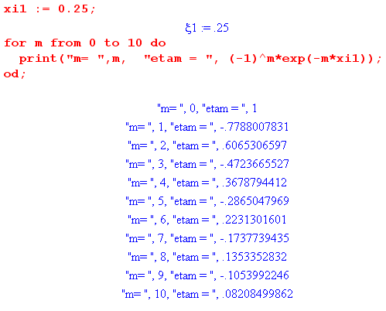

And I noted the alternating signs. This is the conductor on the right, and recall how θ is defined, so the terms are additive around θ = π.

2. These moments then determine the Er(r=a-ε,m) via the charge pump BC.

Now, what are the E fields inside my round wire which has some radius a? Without any boundary conditions applied, I have

First summary of the E field solutions (D.2.21)

Ez(r,m) = - j (β'/βd) $\frac{Km}{2}$ Jm(x) x = β'r (D.1.27)

Er(r,m) = am x-1 Jm(x) + $\frac{Km}{2}$ Jm+1(x) β'2 = β2 - βd2 (D.2.11)

jEφ(r,m) = - am x-1 Jm(x) + ( $\frac{Km}{2}$+ $\frac{am}{m}$ ) Jm+1(x) (D.2.15)

where I don't know the am and Km coefficients, they could be anything for each mode.

If I believe my own "charge pumping condition", then lines doc says

Er(r=a-ε,m) = (jω/σ) Nm . [ still valid on 3/6/14 ] (D.2.25)

This says

Er(r=a-ε,m) = (βd/2πωa) I (jω/σ) (-1)m exp(-|m|ξ1)

= (βd/2πa) I (j/σ) (-1)m exp(-|m|ξ1)

This condition is only one boundary condition and it is this from lines doc

am xa-1 Jm(xa) + $\frac{Km}{2}$ Jm+1(xa) = (jω/σ) Nm (1)

The big problem now is finding a second boundary condition!!! Maybe I will find something new here! Apart from m = 0, all the Bessels vanish at r = 0, so we don't get anything new there.

How about this idea:

∫Jz dA = I

Well, only the m = 0 contributes, and I have already done that. Too bad.

3. Erroneous Development of the "two circles" Contradiction

But, in order to get the moments, I had to solve the capacitor problem, and in that problem I assumed that Eφ = 0 at the surface. [ if you set Ax= Ay= 0; what was really assumed was φ = constant ] This does not mean that Eφ = 0 inside, keep that in mind, so it is only on the surface that we have these rings. This then does imply that Ez(r=a,θ) will be constant all around! [ huh? Where does this claim come from? See Note below. ]That does not necessarily mean that the current density is uniform inside, but around the surface you must have Jz be the same going all around, and that then allows Zs to be independent of θ. [ but this is completely wrong as following note comments. ]

Note added 3/6/14: With the "two circles separated by dz" idea, each circle has constant φ and so all the way around there is a constant dφ between the two circles. If you think that Ez = -dφ/dz, then you get a constant Ez and Jz around the perimeter. Another way to say this is dφ/dz = -jβdφ and so φ = constant says that dφ/dz = constant, and IF Ez = -dφ/dz, then Ez = constant. BUT in fact Ez = -dφ/dz - jωAz . The first term is constant around the circle, yes, but the second term Az is not constant on the circle except for the "perfect conductor". In this limit, Az = constant and Ez ≡ 0 all the way around -- a constant. Remember that a very small percentage variation of Az on the circle results in a large variation in Ez because Ez is a tiny difference between two large terms in Ez = -dφ/dz - jωAz .

In the case of the gapped "slotline", you would solve the capacitor problem, and you would assume that φ was constant on the rectangular perimeter in order to do that. There would be charge density on all surfaces of both conductors, just not very strong far from the slot. But the equivalent of Eφ would have to be zero on the surface in order to get those constant-potential cross sections you assumed for the capacitor problem. So you could measure ΔV anywhere on a conductor's perimeter for some dz and get the same thing. [ same wrong idea as above ]

So this might alleviate my Zs(θ) problem. [ but no, Zs(θ) really does vary strongly with θ ! ]

I said at one point that if you add up all the moments, you will find that Zs depends on θ, but that must be wrong! [ no, it is right! ]

Zs(φ) = (1/I) $\sum_{m = -∞}^{∞}{}$ Ez(a,m) ejmφ // (D.1.3a)
= (1/4) Rdc $\sum_{m = -∞}^{∞}{}$ ηm [$\frac{xaJm(xa)}{Jm+1(xa)}$ - $\frac{xaJm(xa)}{Jm-1(xa)}$ ] ejmφ // (D.2.33)

When you add all this up, you will get a result with no φ dependence. How can that possibly happen? [ it can't] If this is a Fourier Series expansion, the only way to get Zs(φ) = constant is this

Ez(a,m) = 0 for all m ≠ 0

But looking at (D.2.33) that says

(1/4) ηm I Rdc (aβ') [$\frac{Jm(xa)}{Jm+1(xa)}$ - $\frac{Jm(xa)}{Jm-1(xa)}$ ] = 0

which requires that

[$\frac{Jm(xa)}{Jm+1(xa)}$ - $\frac{Jm(xa)}{Jm-1(xa)}$ ] = 0

but this just is not true! It would require basically that

Jm+1(xa) = Jm-1(xa)

Even simpler, we know that

Ez(r,m) = - j (β'/βd) $\frac{Km}{2}$ Jm(x)

so you would need

$\frac{Km}{2}$ Jm(xa) = 0

Status: I have some kind of contradiction built into the solution in Appendix D. But I thought Appendix D was all done exactly, full Maxwell equations and so on. Maybe the ansatz of wave is bad?

[ Appendix D is OK, there is no built in contradiction. The contradiction arises from rigidly assuming that Az is exactly constant on the conductor perimeter along with φ being constant. The confusion is understandable, since I assumed just this fact about Az in Chapter 4 ! ]

What about Eφ at r= a?

Eφ(r,m) = (1/4) ηm I Rdc (aβd) [ - $\frac{2mx-1Jm(x)}{Jm-1(xa)}$+ $\frac{Jm+1(x)}{Jm+1(xa)}$ + $\frac{Jm+1(x)}{Jm-1(xa)}$ ]

Eφ(a,m) = (1/4) ηm I Rdc (aβd) [ - $\frac{2mxa-1Jm(xa)}{Jm-1(xa)}$+ $\frac{Jm+1(xa)}{Jm+1(xa)}$ + $\frac{Jm+1(xa)}{Jm-1(xa)}$ ]

Maple shows this really is identically 0, so we do have Eφ(a,m) = 0 for all m. [ well it has to be since I assumed this as a boundary condition to determine the constants an and Kn ] Therefore, any cross section circle has φ = constant. Oops, I forgot about Az!!! [ about time! ]

E = - grad φ - ∂tA

Ez = -∂zφ -jωAz

Ez = jβdφ -jωAz

Since Az ≠ constant on the circle in general, Ez is also not constant, so Zs is also not constant! [ right ]

Mystery resolved: Since Az(C) ≠ constant (see my B field line plot), although φ(C) = constant, you cannot conclude that Ez(C) = constant, and therefore you should find Zs ≠ constant, and that is exactly what I found above! [ correct ]

4. Compute and Plot Az for two cylinders (uniform current)

Here for DC I compute Az for two cylinders. I start with the Helm integral, but then I realize all I have to do is add up the results of Appendix B for each cylinder using superposition. That answer is stated below. I go ahead and plot this Az(x,y) as a plot3d in contour mode, look down from the top, and it gives exactly those B contours I got elsewhere. This sort of confirmed my idea that B field lines are Az contours. I then did my implicitplot for Az(x,y) = various constants, and that gave me the famous labeled picture I used in lines doc now as Fig 3.6b! It is all right here including code.

Do I have an expression for Az for the two cylinders at low frequency? Well I do have this,

Az12(x) = $\frac{μ}{4π}$ i(z) $^{\int_{-∞}^{∞}{}}$dz'{ $^{\int_{C1}^{}{}}$dx1' dy1' b1(x1',y1') $\frac{1}{R1}$– $^{\int_{C2}^{}{}}$dx2' dy2' b2(x2',y2') $\frac{1}{R2}$ } (4.9.1)

But I have never done this integration for uniform current density (that I can remember). Then in Section 5.2 I process this a bit,

Az(x,y,z) = $\frac{μ}{4π}$ i(z) Azt(x,y)

[ ∇t2 + (β2 - kA2)] Azt(x,y) = 0 (5.2.8)

If I think of losses as low this is just Laplace, but my boundary conditions are then no good and there is nothing I can do with this thing! [ that is, I cannot find Az by solving the ODE as I did for φ.] The only way is a brute force calculation. Let's go back to this picture

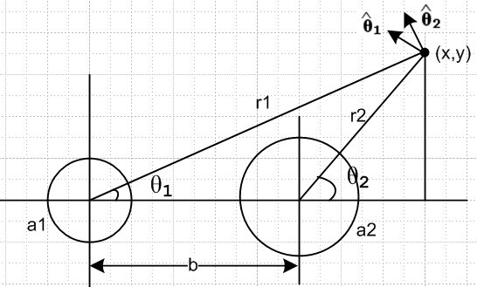

b1(x1',y1') = (I/πa12) θ(r1<a1)

b2(x2',y2') = (I/πa22) θ(r2<a2)

Az12(x) = $\frac{μ}{4π}$ i(z) $^{\int_{-∞}^{∞}{}}$dz'{ $^{\int_{C1}^{}{}}$dx1' dy1' b1(x1',y1') $\frac{1}{R1}$– $^{\int_{C2}^{}{}}$dx2' dy2' b2(x2',y2') $\frac{1}{R2}$ } (4.9.1)

Now write

$^{\int_{C1}^{}{}}$dx1' dy1' = $^{\int_{C1}^{}{}}$r1dr1dθ1 and similarly, so

Az12(x) = $\frac{μ}{4π}$ i(z) $^{\int_{-∞}^{∞}{}}$dz'{ $^{\int_{C1}^{}{}}$ r1'dr1'dθ1 b1(r1') $\frac{1}{R1}$– $^{\int_{C2}^{}{}}$ r1'dr1'dθ1' b2(r2') $\frac{1}{R2}$ }

Now you have to imagine a source point inside the a1 circle at some r1' and θ1'. Then

R1 = | x,y - r1',θ1'| = | r1,θ1 - r1',θ1'|

R12 = r12 + r1'2 - 2r1r1' cos(θ1' - θ1) + (z')2 assume picture is at z' = 0

So at this point we install the uniform current expression and continue:

Az12(x) = $\frac{μ}{4π}$ i(z) $^{\int_{-∞}^{∞}{}}$dz' *
{ $^{\int_{C1}^{}{}}$ r1'dr1'dθ1 (I/πa12) θ(r1<a1) $\frac{1}{R1}$ – $^{\int_{C2}^{}{}}$ r1'dr1'dθ1' (I/πa22) θ(r2<a2) $\frac{1}{R2}$ }

Az12(x) = $\frac{μ}{4π}$ i(z) $^{\int_{-∞}^{∞}{}}$dz' *
{ (I/πa12) $^{\int_{C1}^{}{}}$ r1'dr1'dθ1 θ(r1<a1) $\frac{1}{R1}$ – (I/πa22) $^{\int_{C2}^{}{}}$ r1'dr1'dθ1' θ(r2<a2) $\frac{1}{R2}$ }

Az12(x) = $\frac{μ}{4π}$ i(z) $^{\int_{-∞}^{∞}{}}$dz' *
{ (I/πa12) $^{\int_{0}^{a1}{}}$ r1'dr1'$^{\int_{0}^{2π}{}}$dθ'1 $\frac{1}{R1}$– (I/πa22) $^{\int_{0}^{a2}{}}$ r2'dr2'$^{\int_{0}^{2π}{}}$dθ'2 $\frac{1}{R2}$ }

R12 = r12 + r1'2 + (z')2 - 2r1r1' cos(θ1' - θ1) = s12 + z'2
R22 = r22 + r2'2 + (z')2 - 2r2r2' cos(θ2' - θ2) = s22 + z'2

Following Appendix J, at this point I do the dz' integration with a cutoff

$^{\int_{-∞}^{∞}{}}$ $\sqrt{s2 + z'2}$ = -2ln(s/Λ)

So then I have

Az12(x) = $\frac{μ}{4π}$ i(z) (-1)
{ (I/πa12) $^{\int_{0}^{a1}{}}$ r1'dr1'$^{\int_{0}^{2π}{}}$dθ'1 ln(s12) – (I/πa22) $^{\int_{0}^{a2}{}}$ r2'dr2'$^{\int_{0}^{2π}{}}$dθ'2 ln(s22) }
So
- Az12(x) = $\frac{μ}{4π}$(I/πa12) $^{\int_{0}^{a1}{}}$ r1'dr1'$^{\int_{0}^{2π}{}}$dθ'1 ln(s12) - second term

= $\frac{μI}{4π2a12}$$^{\int_{0}^{a1}{}}$ r1'dr1'$^{\int_{0}^{2π}{}}$dθ'1 ln(s12) - second term

where now

s12 = r12 + r1'2 - 2r1r1' cos(x)
s22 = r22 + r2'2 - 2r2r2' cos(x)

I have already computed the first term in (B.7.3) where I found that

Az12(c)(r1>a1) = - $\frac{μI}{2π}$lnr1 (B.7.7)
Az12(c)(r1<a1) = $\frac{μI}{2πa12}$ { (a12-r12)/2 - a12lna1 }

This is just the first of my two terms. I can write

Az12(x,y) = - $\frac{μI}{2π}$lnr1 θ(r1>a1) + $\frac{μI}{2πa12}$ { (a12-r12)/2 - a12lna1 } θ(r1<a1)
+ $\frac{μI}{2π}$lnr2 θ(r2>a2) - $\frac{μI}{2πa22}$ { (a22-r22)/2 - a22lna2 } θ(r2<a2)

So I think this is the final answer, and it is fairly messy.

r12 = x2 + y2 r22 = (x-b)2 + y2

But this is the first time I have written down this explicit result. [ how about a Maple plot! See below]

Can I do a numeric dsolve of Az12(x,y) = 3 ? It happens that I have no derivatives in my equations. I will try this in Az lines 1.mws. Rewrite

t1 t3
$\frac{2π}{μI}$Az12(x,y) = - lnr1 θ(r1>a1) + { (1-r12/a12)/2 - lna1 } θ(r1<a1)
+ lnr2 θ(r2>a2) - { (1-r22/a22)/2 - lna2 }/ θ(r2<a2) ≡ f(x,y)
t2 t4

r12 = x2 + y2 r22 = (x-b)2 + y2

I just want Maple to deal with something like f(x,y) = 3, where there are no derivatives, but dsolve always wants an initial condition. [ see "Az lines 1.mws" ]

OK, if I just do a plot3d contour plot of f(x,y) I get this nice thing

Maple program is: Az lines 1.mws

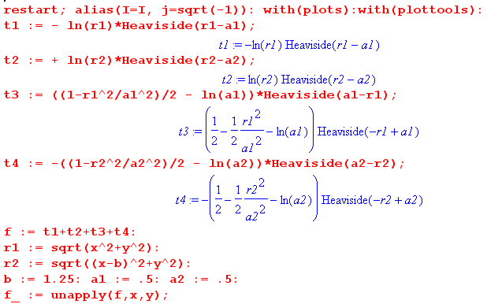

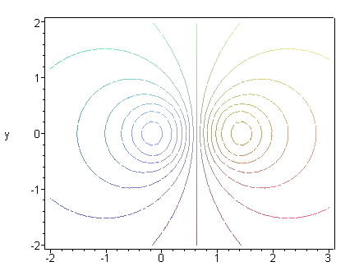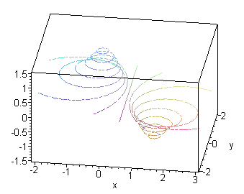

and sure enough it looks JUST LIKE my B field line picture, as I hoped it would. Here is a cross section at y = 0 to show that nothing singular happens at the max and min points,

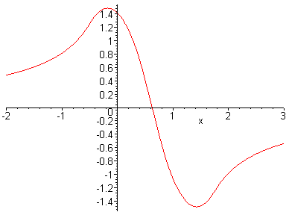

I have this now also as an implicitplot,

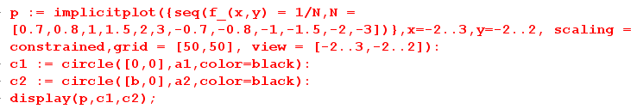

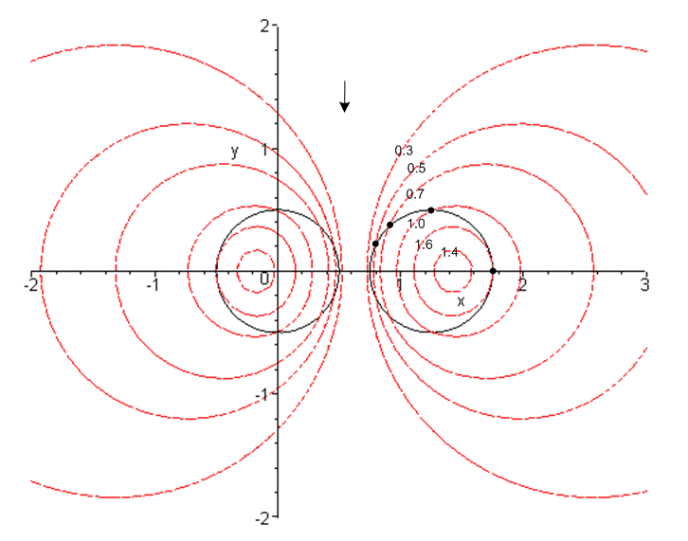
[ The numbers in this picture are wrong, I edited Az lines 1.mws to make things right and the right numbers now appear in lines doc as Fig 3.6b. . ]

I am now quite satisfied that lines of constant Az12 are the same as the B field lines [ as shown in "the field line mapping problem.doc". And you see explicitly above that Az is not constant on the conductor surfaces, just as in the B field plots. For example, on the right black circle I show points with Az = 1.6, 1.0, 0.7, 0.5 . This shows that Az varies substantially on the black circle, just as you would think.

Note Added 3/6/14. This is a typical result at DC -- the B field lines and the Az equipotentials do NOT align with the boundaries, and you know this will also be true for low frequencies certainly, so here is real-world evidence that the "W(z) Hypothesis" of Chap 4 is not generally correct and needs some restrictions (perhaps to strong skin depth limit).

