Study of the Ch 6 solution PhL 2.16.14

Final review 5.14.14: This is where I developed the theory of the two cylinder capacitor in bipolar coordinates. This is now all written up in bipolar doc which took about 10 days to write and publish. It also serves as the basis for lines doc Chapter 6.5 on proximity effect. Can ignore what is below.

Motivation: I would like to see details of the "fat twin lead" geometry. What is n(φ), what is E, what does the active perimeter look like.

1. Bipolar Coordinates

I have to go look at my doc on this subject as I did for my Dec email friend. My first picture is the MF bipolar coordinates with ξ and θ. Then I change from θ to u, and I get this block of equations,

x = ashξ/(chξ–cosu) hξ = hu = a/(chξ–cosu) y/x = sinu/shξ
y = asinu/( chξ–cosu)

ξ = tanh-1[2ax/(a2+ x2+ y2)]
tanu = [ -2ay/(a2-x2-y2)]

r2 = a2 (sh2ξ + sin2u) / (chξ-cosu)2 tanφ ≡ y/x = sinu/shξ

x2 + (y- acotu)2 = a2/sin2u yc = a cot(u) R = a/|sinu|
(x - acothξ)2 + y2 = a2/sh2ξ xc = acothξ R = a/|shξ|

As usual, in order to find u we have to do our algorithm described above, but here I will be more detailed:

1. Compute ξ = tanh-1[2ax/(a2+ x2+ y2)]
2. Compute cosu = chξ - (a/x)shξ
3. Compute sinu = (y/x)shξ.
4. Compute u = arctan2P(cosu,sinu)

Here are some of the u labels,

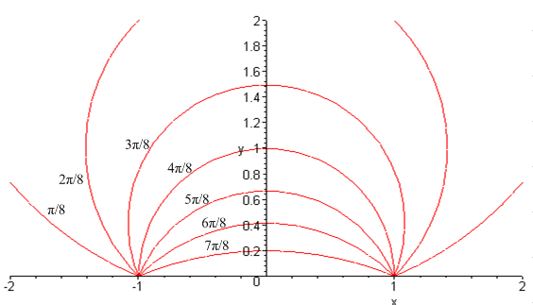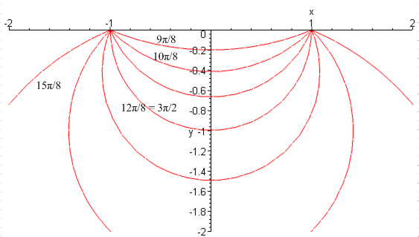

Now, what is the connection between ξ and B of lines doc? I use a in place of d there. Compare:

ln [| r - a| / | r + a| ] = -ξ

|x-x2| / |x-x1| = e-B x2 is on the right and corresponds to a

|x-a| / |x+a| = e-B

ln [ |x-a| / |x+a|] = -B

Excellent!!! We have ξ = B exactly.

The potential is given by

φ(x,y) = ln { [(x-d)2 + y2]/ [(x+d)2 + y2] }

2. Setting up Parameter Values for a Fat Twinlead

Looking at a particular blue circle on the right side labeled by B > 0, we have

xc = d / thB r = d/shB

Fact: I plot both the above for B = 0 to 10, and find that xc > r always, so blue circle all on right.

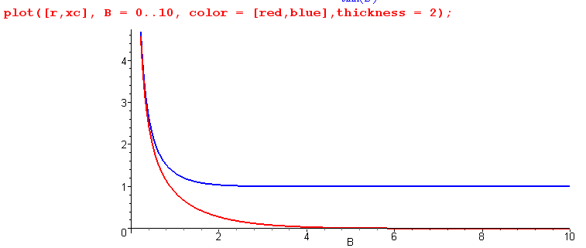

You can see that the radius (red) approaches r = 0 as B gets large, while xc approaches d = 1.

The intersections of this blue circle with the x axis are found by setting y = 0 in the circle equation.

(x - xc)2 + y2 = r2

so that

(x - xc)2 = r2 x - xc = ± r x = xc ± r

The intersection closest to the y axis is

x1 = xc - r = d / thB - d/shB = d [ 1/thB - 1/shB ]

As noted above, we always have xc > r, so x1 is always positive (assuming B > 0).

The parameters I want to "set" are these

r = d/shB

x1 = xc - r = d [ 1/thB - 1/shB ]

For example, I might like to set r = 1 and have x1 = 0.1 to get a fat twin lead. So we have to solve the above equations for d and B that makes this work. First we can say

d = r shB
d = x1/ [ 1/thB - 1/shB ]

Then we can solve for B as follows

r shB = x1/ [ 1/thB - 1/shB ]

[ 1/thB - 1/shB ] shB = x1/r

[ chB/shB - 1/shB ] shB = x1/r

[ chB - 1 ] = x1/r

chB = 1+ x1/r (*)

B = ch-1(1 + x1/r)
d = r shB

Now I want x1 = .05 and r = 1.00 so this says

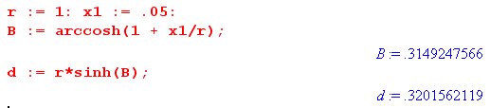
Now I draw the cat's eyes with these values

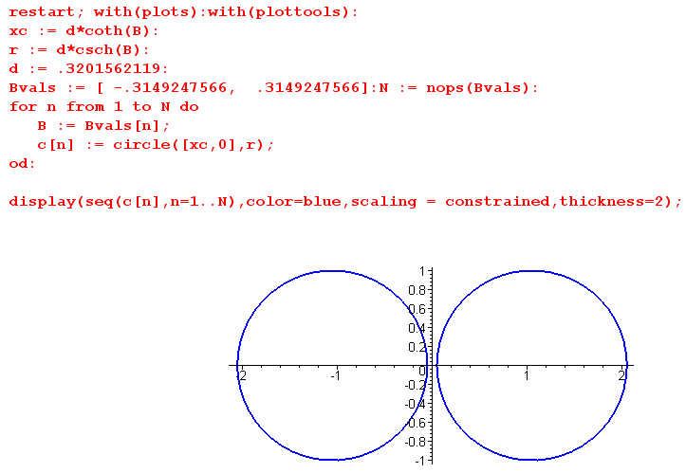

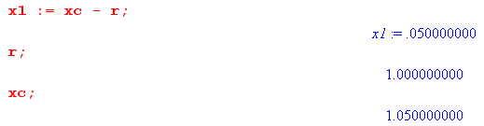
2. What is the potential?

φ(x,y) = ln { [(x-d)2 + y2]/ [(x+d)2 + y2] } d = .3201562119 B = .3149247566

What does this look like in bipolar coordinates? I have Maple compute this for me:

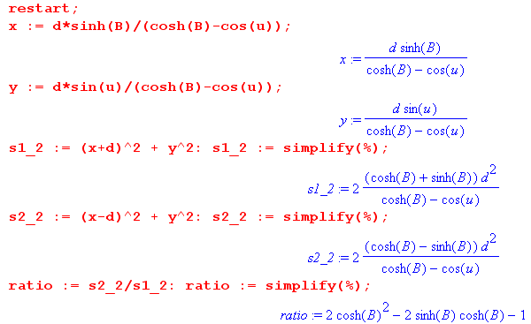

Here are other ways to write this ratio:

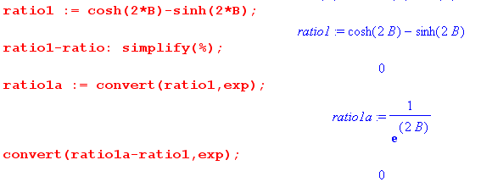

Therefore,

φ(B,u) = ln(s22/s12) = ln(ratio1a)

= ln [ e-2B] = -2B

Thus, as expected, the potential is a function only of B and not of u, and it is an exceedingly simple function of B!!

3. What is the electric field?

How might I compute the electric field directly in bipolar coordinates?

Well, my first action will be to copy in my summary section from tensor doc,

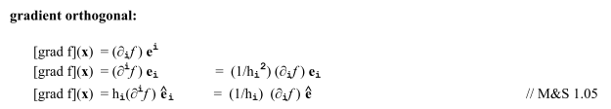

(errata documented) Now what does this all mean? B u

Recall that the i are unit vectors in x space which point in the direction if increasing coordinate, much like for sphericals. So let's use the line above which says

[grad φ](x) = (1/hi)∂iφ i

It is normal to use ∂i for a gradient, this is ∂/∂xi and ∂i is a covariant vector.

Now in our case we have

hB = hu = d/(chB–cosu)

But our potential is φ(B,u) = φ(B) so only the "1" component. Then we have

[grad φ](x) = (1/hB)∂Bφ B

= [(chB–cosu)/d ] ∂B [-2B] B

= -2 [(chB–cosu)/d ] B

then the electric field is this

E(x) = - [grad φ](x) = 2 [(chB–cosu)/d ] B

Now since chB > 1 always, the factor is positive, and this says E points in the B direction which is this:

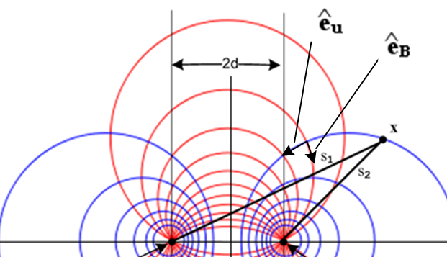

Thus, the E field points into the blue circle on the right and is normal to that circle. This suggests that the right circle has negative surface charge! How could I confirm that fact?
Let's go back to,

φt(x) = ln(s22/s12) = ln [$\frac{(x-d)2 + y2}{(x+d)2 + y2}$] = -2B

Suppose we think of this always at y = 0 so that

φt(x,y=0) = ln [$\frac{(x-d)2}{(x+d)2}$]

If I plot this versus x, I get

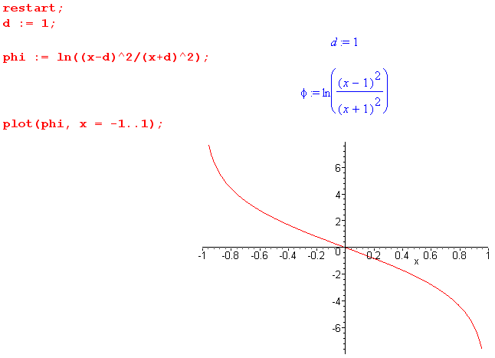

Now we know that Ex = -∂xφ = positive at all locations x. Thus, Ex "points to the right", in agreement with what was found above in bipolar coordinates. The positive charge is on the left.

Now let's install our little values of interest. Recall

d = .3201562119
B = .3149247566

E(x) = - [grad φ](x) = 2 [(chB–cosu)/d ] B

EB = 2 [(chB–cosu)/d ]

First we know from (*) above that

chB = 1+ x1/r

d = r shB = r$\sqrt{ch2B-1}$ = r$\sqrt{(1+x1/r)2-1}$ = r$\sqrt{x12/r2+2x1/r}$ = $\sqrt{x12+2x1r}$ =$\sqrt{x1(2r+x1)}$

In our current interest, x1 << r, so d ≈ $\sqrt{2x1r}$ and chB ≈ 1 so we then have

EB(u) = 2 (1–cosu)/ $\sqrt{2x1r}$ = $\sqrt{2/x1r}$(1–cosu)

No matter how small you make x1, this curve always has the same SHAPE.

Conclusion: In the fat twinlead problem, as the fat wires are brought closer and closer together, you reach a limiting form for the normal E field as a function of u. This normal E field component plot can be regarded as a plot of the surface charge density as well. Here it is

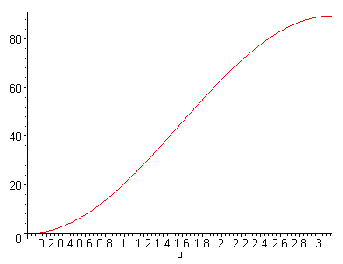

The meaning of variable u

