The field-line mapping problem PhL 2.28.14

1. Here I "discover" a better way to map out field lines using the Maple dsolve command. I got a hint from the web. I want a parametric solution x = X(s) and y = Y(s) and I show that X(s) and Y(s) must be the solutions two a pair of first-order coupled non-linear ODE's

(∂X/∂s) = α(s) f(X(s),Y(s))
(∂Y/∂s) = α(s) g(X(s),Y(s))

But Maple is an expert at providing a numerical solution for X(s) and Y(s) for equations like this! Thus, you have your field lines!

2. I then use this new (and faster!) method to compute the H field lines from the Hx and Hy known expressions for the DC two-cylinder problem (uniform Jz). Eventually I can try this for the rectangular conductor and update lines doc!

3. For thin wires, I have another field lines method that gives an analytic solution for field lines.

4. I then show that in this case, all the field lines are Apollonius circles, and I explain why that is the expected result.

5. For the fat DC cylinders, you get those Apollonius circles anywhere outside the wires, but inside you get a more complicated solution.

6. Approaching either from the inside or the outside, the fat cylinder circles do NOT align with the H field lines! Thus, there is always an Hn component at the boundary.

7. Maybe you could apply the analytic method to the inside of a conductor and get an analytic form.

1. A Numerical Field-Line Method 1
2. That Numerical Method applied to the two cylinder problem 3
3. An analytic field-line method applied to the two-thin-wires problem 8
4. Question: Are these circles the circles of Apollonius? [ answer is yes ] 11

1. A Numerical Field-Line Method

I have avoided working on this problem since Maple can do a rough job numerically just "tracing out" the field lines mechanically.

Statement of problem: You have two functions Hx(x,y) and Hy(x,y), think magnetic field H say. It is trivial to do a field plot of this in Maple and get little arrows. But how, analytically, can you find the equations of the field lines? A field line has the form

x = X(s)
y = Y(s)

where s is a parameter along the field line. We start with

Hx = f(x,y)
Hy = g(x,y)

Given f and g, how do you find X and Y ?

Plan A. Here are a few things I can write out:

dx = (∂X/∂s)ds dr = (∂X/∂s)ds + (∂Y/∂s)ds
dy = (∂Y/∂s)ds

dHx = (∂xf)dx + (∂yf) dy dHx = ∇f • dr
dHy = (∂xg)dx + (∂yg) dy dHy = ∇g • dr

dH = [∇f • dr] + [∇g • dr]

I think I want dr = α(s) ds H at any point on the field line marked by s where α(s) is any positive function which controls the "speed" of the parameter s. OK if one sets α(s) = 1.

Well, then

α(s) ds H = dr = (∂X/∂s)ds + (∂Y/∂s)ds

α(s) ds [ Hx + Hy ] = (∂X/∂s)ds + (∂Y/∂s)ds

α(s) ds [f(x,y) + g(x,y) ] = (∂X/∂s)ds + (∂Y/∂s)ds

α(s) f(x,y) = (∂X/∂s)
α(s) g(x,y) = (∂Y/∂s)

α(s) f(X(s),Y(s)) = (∂X/∂s)
α(s) g(X(s),Y(s)) = (∂Y/∂s)

(∂X/∂s) = α(s) f(X(s),Y(s))
(∂Y/∂s) = α(s) g(X(s),Y(s)) (*)

This looks like a pair of coupled, non-linear, first order differential equations.

Does Polyanin have anything to say about this? No, this is much too general a form even for first order.

Conclusion: I don't think one can find closed form analytic solutions to this problem for arbitrary f and g functions.

But, while web scanning I noticed that Mathematica has a routine NDSolve which can numerically solve any ODE you want, linear or non-linear! Does Maple have such a thing? I never even thought of looking until just now. // Yes it does, so I wrote up a little for Maple folder storage on how this works.

2. That Numerical Method applied to the two cylinder problem

Note: The equations below for the H fields were derived in another doc called "the surface currents issue.doc". Here I am just using these equations to try to draw field lines. The equations are valid both inside and outside the conductors and apply at DC only where we assume a uniform Jz density. We assume that the B field of one conductor does not alter the current density in the other conductor, for example. This would involve the Lorentz Force, something I have never faced up to. I think this just results in a force on the two cylinders and not an alteration in the Jz pattern.

I will now try to make dsolve work with (*) above:

Hx = - (y/r1)H1(r1) - (y/r2) H2(r2)
Hy = (x/r1) H1(r1) + ((x-b)/r2) H2(r2)

H1(r1) = (I/2π)[ θ(r1>a1) (1/r1) + θ(a1>r1) (r1/a12)]
H2(r2) = -(I/2π)[ θ(r2>a2) (1/r2) + θ(a2>r2) (r2/a22)]

I think the θ functions will mess up dsolve! Perhaps this is a bad example for dsolve. Not trying it.

Next day: I tried it anyway and it worked, the Heaviside's I guess were treated like any other function. Here is the code and the result: Code is in file: field lines 1.mws

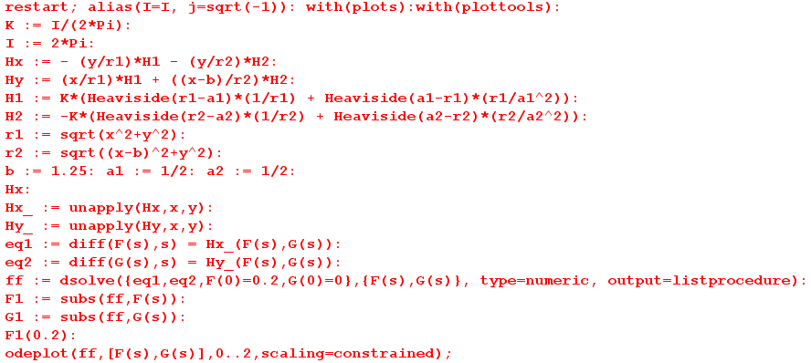

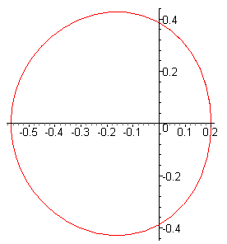

The code runs instantly, it would have taken my iterator about 30 seconds to draw this curve! Wow, I am really stunned by this. My "theory" above must have been done correctly, that is also amazing. Let's try to get this thing to add the two circles. No problem!

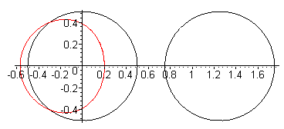

What is going on here with "loop around". If I plot the separate functions, I see it is going around about 1.7 times, but I guess it just overwrites on the plot. Yes, and it you run it with lots of loops, the plot gets ragged.
If I pick the x = 0.4 starting point, things are not as good, we get some jaggies.

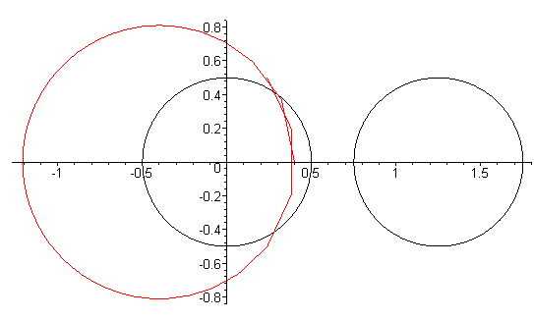

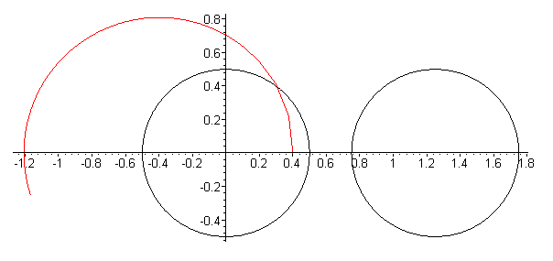
You see jaggies right at the start here, so we need more precision somehow. After fiddling, I learned this is just an issue with setting numpoints in the odeplot routine. Here is the new curve

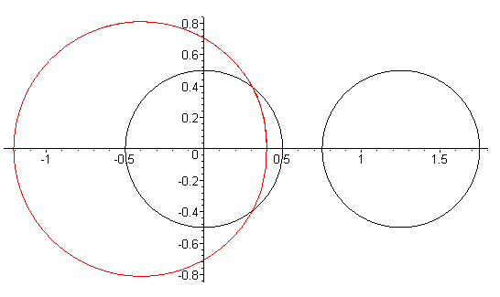

and the jaggies are gone. Very good.

Now let's try to get a set of curves instead of just one. // Not too hard, here are 12 curves

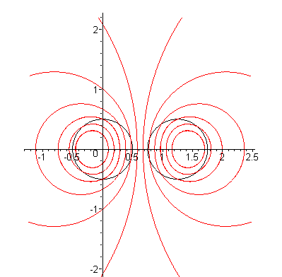

Next, I need to compute a range of s for each curve somehow so we don't get wrapping. // Got that done, it took a little work. Here is a picture with 16 curves properly spaced:

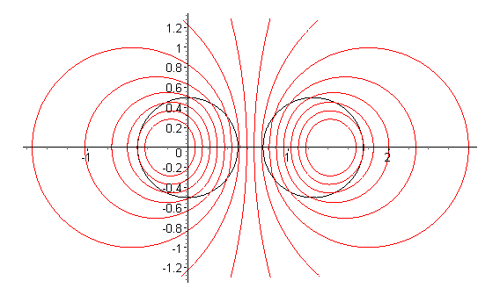
I think I could do field lines for the rectangular bar this way. But don't get into that right now! Add that later on when other problems are fixed.

Question: Outside the conductors are the curves perfect circles? Here is for smaller radii:

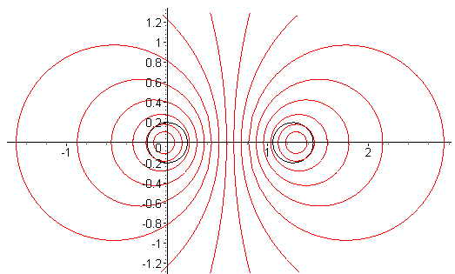

They sure look like circles to me.

3. An analytic field-line method applied to the two-thin-wires problem

Here I show that for the two-wire problem (no Heavisides then) you can "integrate $\frac{dy}{dx}$ = Hy/Hx and get a closed form solution for the field lines loci, and this is NOT a numerical method. This results in loci that are circular and this then explains why the lines in Section 1 look so much like circles (they are circles!)

Plan B. Let's go back a ways now in the theory section to this point:

dr = α(s) ds H

Then one can say

dy = α(s) ds Hy
dx = α(s) ds Hx

$\frac{dy}{dx}$ = Hy/Hx

In doing the ratio, it is likely that some common factors cancel out and we can write this in a simpler form as

$\frac{dy}{dx}$ = hy/hx
so
hx(x,y) $\frac{dy}{dx}$ = hy(x,y)

Now this is a non-linear first order ODE that might be relatively simple and might be solvable for y(x). Then you have a direct locus for your solution! Maybe Maple can solve the thing and you can see perhaps whether your loci are circles !
For our general problem above with its Heaviside functions, things are not very simple. BUT, if we consider the case of just two thin wires, then things are in fact quite simple! Here is some code:

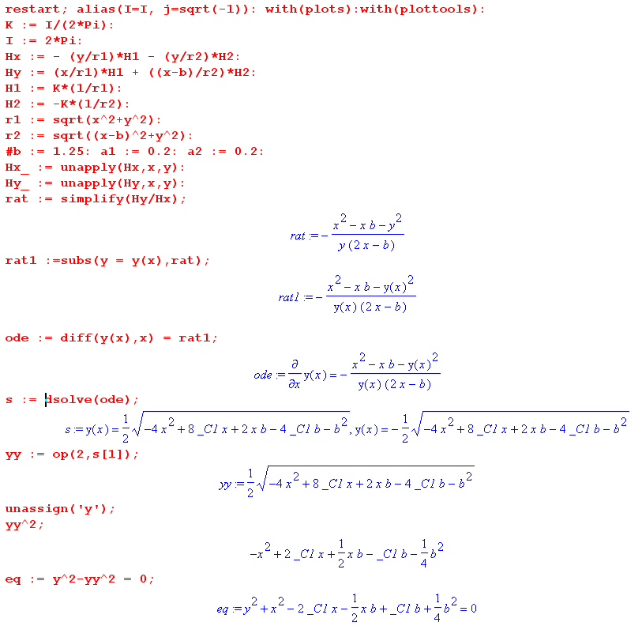
The last item here is the locus where _C1 is a single unknown constant. Maple can complete the square for the x part,

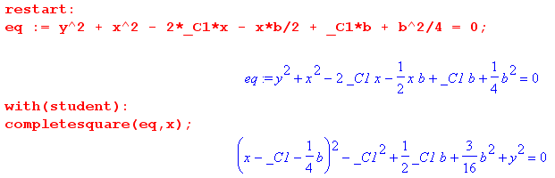

which is then

(x - b/4 -C1)2 + y2 = C12 - bC1/2 - 3(b/4)2

There it is! Replace constant with simpler c

(x - b/4 -c)2 + y2 = c2 - bc/2 - 3(b/4)2 = c(c-b/2) - 3(b/4)2

The form is then

(x-xc)2 + y2 = r2

xc = b/4+c r2 = c2 - bc/2 - 3(b/4)2

The condition that r2 be positive says

c2 - bc/2 - 3(b/4)2 > 0

For this quadratic we have

B2 - 4AC = b2/4 - 4*1*(-3)(b/4)2 = b2/4 + 12(b/4)2 = b2[ 1/4 + 3/4] = b2

c = [ b/2 ± b]/2 = [ b ± 2b]/4 = b/4 ± b/2

which is very strange. These are the two values of c that give zero radius. At those values we have

xc = b/4+c = b/4+ b/4 ± b/2 = b/2 ± b/2 = 0 and b

as expected.

Here is a plot where I set the circle radii to .01 so they are hard to see.

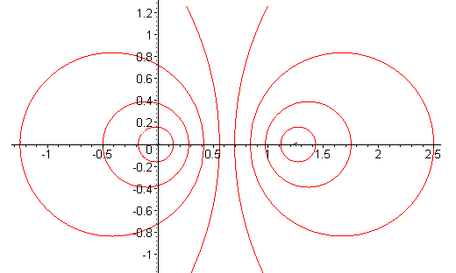

4. Question: Are these circles the circles of Apollonius? [ answer is yes ]

They sure look like it. The equations found above were

(x-xc)2 + y2 = r2

xc = b/4+c r2 = c2 - bc/2 - 3(b/4)2

How can I get these circles "centered" in the Apollonius sense? I would like x → x-b/2. Then we would have xc → xc - b/2 and centered we would have [ b/4 - b/2 = -b/4]

(x-xc)2 + y2 = r2

xc = - b/4+c r2 = c2 - bc/2 - 3(b/4)2

Bipolar doc on the other hand gives,

(x - xc)2 + y2 = R2 xc = a/thξ R = a/|shξ| (2.4)

So to make them compatible, we would have to set

a/thξ = -b/4+c and a/|shξ| = [ c2 - bc/2 - 3(b/4)2]1/2

where recall that b is the center separation and c is "some constant". It seems pretty likely that you can find parameters a and ξ which solve these two equations. But the question really is this:

Can you find a fixed value of a such that the red curves above are each described by that same a, and a different value of ξ? We know that

coth2x = 1 + csch2x

1/th2x = 1 + 1/sh2x

Now consider

1/th2ξ = (-b/4+c)2/a2

1/sh2ξ = (c2 - bc/2 - 3(b/4)2)/a2

Then we have

(-b/4+c)2/a2 = 1 + (c2 - bc/2 - 3(b/4)2)/a2
or
(-b/4+c)2 = a2 + (c2 - bc/2 - 3(b/4)2)
or
a2 = (-b/4+c)2 - (c2 - bc/2 - 3(b/4)2) = b2/4

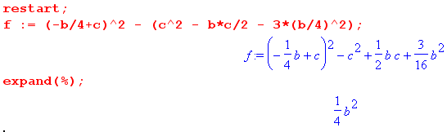

Thus, parameter a = b/2 as one would expect, and a is independent of c. Then the equations are

(b/2)/thξ = -b/4+c and (b/2)/|shξ| = [ c2 - bc/2 - 3(b/4)2]1/2

and can we solve to get ξ ? Divide to get

shξ/thξ = (b/4+c)/( c2 - bc/2 - 3(b/4)2) = chξ

So it would seem that

ξ = ch-1[(b/4+c)/( c2 - bc/2 - 3(b/4)2)]

OK, we have basically replaced these two equations

a/thξ = -b/4+c

a/|shξ| = [ c2 - bc/2 - 3(b/4)2]1/2

with these two equations

(-b/4+c)2/a2 = 1 + (c2 - bc/2 - 3(b/4)2)/a2

chξ = (b/4+c)/( c2 - bc/2 - 3(b/4)2)

which is to say, these two equations

a = b/2
ξ = ch-1[(b/4+c)/( c2 - bc/2 - 3(b/4)2)]

So the answer is YES, these are standard Apollonius circles.

Comment: Both φ and Az must be solutions to 2D Helmholtz. At DC, they must both solve 2D Laplace. The both have the same boundary conditions for the case of two thin wires, namely, that on the thin wire there is some value of the potential and minus that value on the other wire. So apart from distinction of W and V, the two sets of equipotential curves must be the same. I am a little later on realizing this.

But inside finite size cylinders, things are different, as the plots show.

