Whiteboard picture and commentary PhL 5.9.14

Here is the full whiteboard drawing (blowups appear below) : To see this on Alta, set to 250% and have a whole screen window, you can see everything just fine. On the left, if At= 0 and Eθ = 0, you get φ = constant. Then the capacitor problem determines n(θ) and Nm which don't vary with ω. These get into the solution via the Er CP boundary condition and Km and am are then determined. You end up with the Jz asym problem at ω → 0. See last red paragraph at the end below.

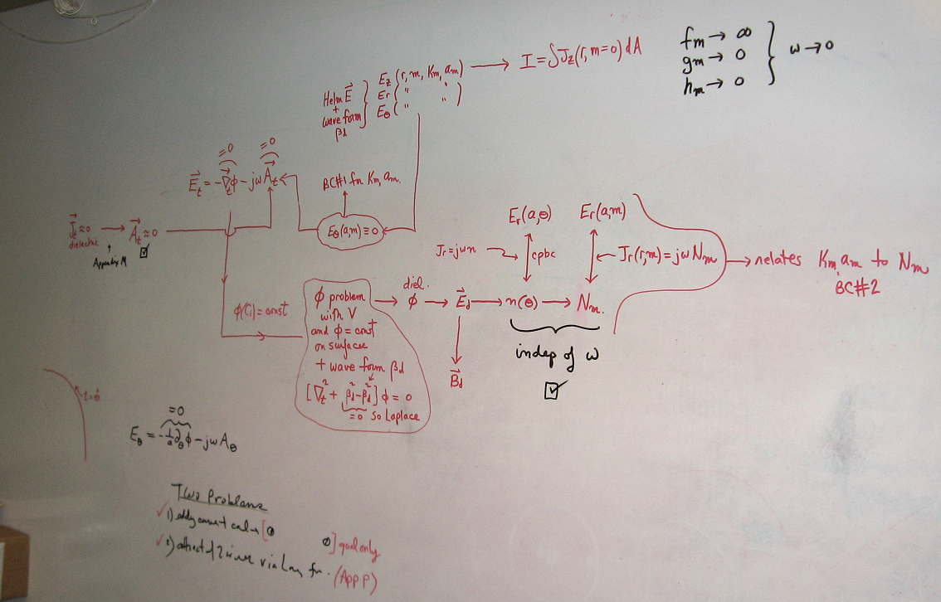

I will start on the left side:

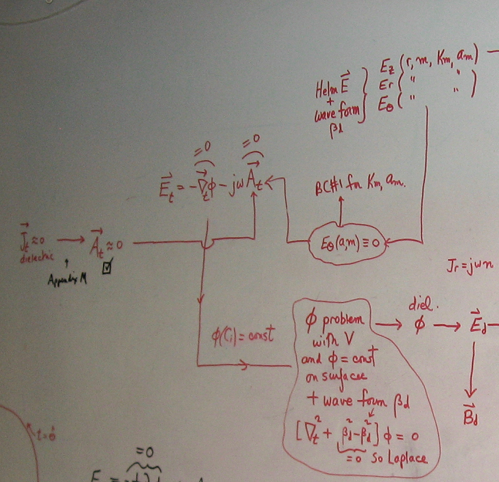

Here then is a verbal description. On the left, in a transmission line the main current is Jz in the conductors, so Jt is small. By the arguments of Appendix M, At is therefore small, though the whiteboard does not say how small (but I have a doc which answers that question). The smallness of both Jt and At are true for all frequencies up to say the transmission line limit, and this includes arbitrarily low frequencies. Assuming At ≈ 0, we then get Et ≈ -∇tφ as shown top center. Again, this is true at all frequencies DC up to TL limit, and this is our "quasi-static" aspect of the problem. The upper oval says Eθ = 0 at the surface, and that is one of my two Huge Assumptions, another quasi-static idea. Since Et ≈ -∇tφ , saying Eθ = 0 at the surface implies that φ = constant on the surface, and that fact then feeds into he lower outlined text. That text describes an electrostatics Laplace (Dirichlet) problem in the dielectric which is bounded by the two constant-φ conductors. It is a Laplace problem because we assume "low loss" which I think kills off the Helmholtz parameter as shown. If there were some small loss, presumably we could still solve this 2D transverse problem to get potential φ in the dielectric. For the low-loss case, nothing depends on ω. I will continue this thread below the next picture. Meanwhile, since Eθ = 0 at the surface (upper outlined assumption), this acts as Boundary Condition #1 in Appendix D for a round conductor. This is one of the two BC's from which I get am and Km.
Here then is the right side:

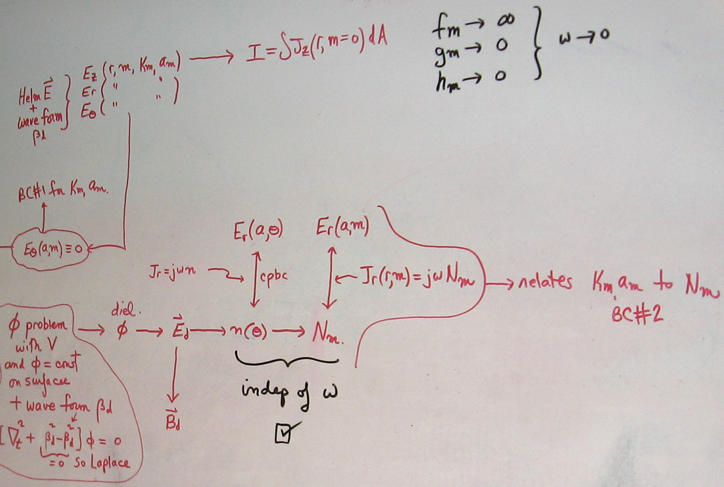

and I continue the above description. We obtain φ in the dielectric by solving the above-described Dirichlet problem. This then determines the electric field Ed in the dielectric (transverse) and then from Maxwell curl E = -jωB we can determined Bd in the dielectric. The field Ed just above a conductor surface determines the charge density n(θ) on the surface and from that we can get the charge density moments Nm. A major idea at this point is that these last two items are independent of ω. They are just the solution of the DC capacitor problem really. The claim then is that apart from ejωt, the potential and field pattern in the dielectric is the same at all frequencies (assuming low loss in the φ problem cloud), including very low frequencies. Our "charge pumping boundary condition" (cpbc) of Appendix D then relates n(θ) directly to the radial E field Er(a,θ) just below the conductor surface (ie, inside conductor), and similarly Er(a,m) is directly related to Nm. Using the general forms of Appendix D, Jr(a,m) = jωNm (notice typo in picture which shows Jr(r,m) ) leads to a second condition on am and Km which I call Boundary Condition #2, or BC#2.
We now look at the top of the picture. Given both BC#1 and BC#2 and given the general forms of Appendix D for the E fields, we get exact expressions for the fields since then am and Km are fully determined and then the problem seems to be fully solved, both inside and outside the conductor. The equation at top center regarding I is a normalization condition for Jz inside the conductor and in lines doc this condition determines N0. The quantities fm, gm and hm are certain Bessel function combinations which appear in the Appendix D E field forms, and the black text shows their limits as ω → 0.
Finally, here is one more region of the picture:

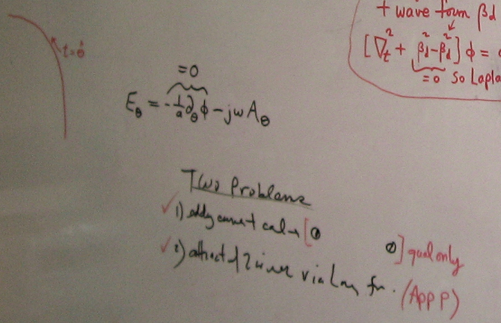

When I drew this picture, I had not yet thought about Eddy Currents (now Appendix P). I had hoped I could find the current asymmetry in a twin lead (drawn in red brackets) using Eddy Current Theory. I was however only able to obtain a "qualitative" graphic eddy current solution in Appendix P. But a key idea of the eddy current theory is that at ω = 0, if there is I > 0 flowing in the wires, there is absolutely no current asymmetry. I firmly established that eddy current analysis does nothing at DC -- there is no DC proximity effect, something I thought might exist (egged on by a lone author that caused a trip to Marriott). So that is the first red-checked item above.
The second item is that I wanted to come up with a theory for why the two parallel wires attract or repel based on the relative current direction. I found an argument and it is inserted into Appendix P, so that item got red-checked too. The Eθ equation (at r = a) shows how I used to think of things. I thought first that φ = constant on surface, so then ∂θφ = 0, and then along with At = 0 this gave Eθ = 0. I now think of Eθ = 0 first (quasi static argument of Appendix D.8 since free charge can exist on the surface), and then I use Aθ = 0 from Appendix P and conclude that φ = constant.

One of my major motivations for drawing this picture in the first place was the low ω limit of the transmission line theory. As I show in Appendix P, for two cylinders carrying I in opposite directions, the current crowding goes away gradually as ω → 0 so at ω = 0 there is no crowding at all. This conclusion is based on eddy current theory. So at ω = 0, there is then no asymmetry at all. At first, I felt this was in major conflict with the transmission line theory. As the above whiteboard drawing and comments show, the asymmetry pattern of n(θ) and thus of Jz is independent of ω! We know that n(θ) is just a result of the capacitor problem, and cannot change with ω. And from BC#2 this eventually gets into Jz causing it to be asymmetric even at ω= 0. So this was a Big Paradox and even now I am uncomfortable about it. I "resolved" the paradox by noting that as ω → 0, the Z0 of a working transmission line → ∞ and then I → 0 for fixed V so there is no current. I guess now in retrospect, as ω→ 0, we have δ → ∞ and we leave the strong skin effect regime, so the whole Chapter 4 theory really breaks down and probably there is no conclusion to be had. I am still working on this issue.

My new Chapter 7 suggests a resolution!

