Notes on Thuras et al on Sound Waves PhL 7.21.11

This is a PDF I downloaded from the web. The authors are interested in the design of audio speakers! Their point is that, as they will show, the "wave equation" for sound propagation in air is not truly linear as amplitudes get large, and this causes the appearance of harmonics, and this is something you should think about if you are designing perhaps PA system horns, or band speakers, etc. They show this non-linearity on page 160 based on the "adiabatic gas law" which I have to defer for a moment, though I certainly remember the idea. I note the use of symbol v = 1/ρ for the m3 per kg of a substance. This inverse quantity is called "the specific volume" of that substance.

Theory of Propagation of Plane Waves of Finite Amplitude

This is exactly the kind of book section I have been looking for. The authors follow the development of Lord Rayleigh (not to be confused with Lord Kelvin), as described in his Theory of Sound book of 1877. The opening picture is very useful and is probably what I have been missing:

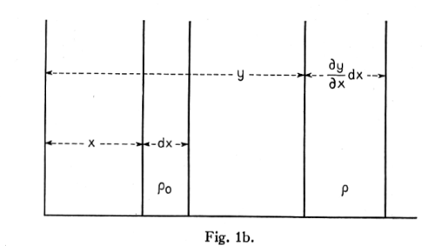

Comment on ∂y/∂x: If you were to increase x a bit, we move to the right in our "wave", and we would expect the displacement ξ to be different at this new x position. Even if ξ were the same, y would be different. In any event, increasing x changes y, so that is the meaning of ∂y/∂x.

The idea is that a "band of air" that would normally be dx wide at position x and have rest density ρ0, is displaced to location y. The position is different from the rest position, AND the width of the band is different so the density is different. So these bands are "the volume that moves" in fluid flow. The thing we call "the displacement" is ξ = y - x: it is the displacement of the band from its rest position. So right off the bat, we get the idea that a wave is going to be describable in both ξ(x,t) and ρ(x,t). I think ξ is the historical symbol used here! I suppose it is fair to say that dy = (∂y/∂x)dx. But if we think of y being y(x,t), we might think of dy = (∂y/∂x)dx+ (∂y/∂t)dt, so maybe that is why he doesn't use dy. I don't think we want time involved here, this is a space picture only, so maybe use δy = (∂y/∂x)dx.
Now we can start into the equations. It seems pretty clear that ρ/ρ0 = dx/δy = (∂y/∂x)-1. We then have

ξ(x,t) = y(x,t) - x => ∂y/∂x = 1 + ∂ξ/∂x // and for later, ∂y/∂t = ∂ξ/∂t

so we obtain [ density expressed in terms of the "dilatation" ∂ξ/∂x ]

ρ = ρ0 (1 + ∂ξ/∂x)-1 (1)

Equation (1) is based entirely on the picture and the concept behind it. This is pretty much a "statics" picture. The matter in the original band is the same as that in the shifted band of air. We have not applied the equation of mass conservation (continuity) really, except to note that mass is the same in both bands and this is why we are allowed to say ρ/ρ0 = dx/δy. ξ is called "the particle displacement". We are doing the Lagrangian particle approach here.

Now we are supposed to use F = ma to get the dynamics. Again, the mass in our two strips is the same, the material just "displaced". The mass is then (assume Area = A = 1 so ignore it)

m = ρδy = ρ0dx a = ∂t2y ma = ρδy∂t2y = ρ0dx ∂t2y

We are talking here about the acceleration of the strip of air now at location y. So the above is the "ma" part. Now we are supposed to ignore frictional forces (viscosity) and just assume F is the pressure difference between the two sides of our strip at y, so F = -δp = -(∂p/∂y)δy . So now we assemble ma = F to get
ma = F
ρ0dx ∂t2y = -(∂p/∂y)δy

ρ0 ∂t2y = -(∂p/∂y)(δy/dx)

ρ0 ∂t2y = -(∂p/∂y) (∂y/∂x)

ρ0 ∂t2y = -(∂p/∂x) // (∂p/∂x) = (∂p/∂y) (∂y/∂x)

ρ0 ∂t2ξ = -(∂p/∂x) // using the above, and this is then (2)

Comment on chain rule (∂p/∂x) = (∂p/∂y) (∂y/∂x). We noted at the start the meaning of (∂y/∂x). A change in x moves us to the right in our "wave" (meaning our solution to the problem, whatever it is) and so y changes. So dx results in a dy. But of course dy causes ρ to change and we know this causes p to change, whether or not we have the ideal gas law. So we have δx → δy → δp where → means "causes a change in". So we have some y = y(x) and then some p = p(y), and everything is a single variable! Time t is frozen, dt = 0. But because t is in the problem, we use partial derivative notation. We are analyzing our picture in t static instant with dt = 0.

Comment of force as a scalar. They claim that pressure p is what you would measure in a Galilean frame traveling with the δy strip. I would have thought pressure p was a Galilean scalar, but they comment on this somewhat. Well as a force, we know that F = dp/dt, and in a Galilean transformation momentum p = mv changes. That is to say, if we observe a single particle to have some dp/dt in one frame, we deduce the presence in that frame of a force F. If we observe the same process in a different frame, we will get F' = dp'/dt, so no, force is NOT a Galilean scalar relative to a transformation boost along the force direction.

Now write [ same dt=0 static idea as described in the above comment ]

(∂p/∂x) = (∂p/∂ρ) (∂ρ/∂x)

From (1) we have

ρ(x) = ρ0 (1 + ∂ξ/∂x)-1

(∂ρ/∂x) = - ρ0(1 + ∂ξ/∂x)-2 ∂2ξ/∂x2

So (2) then becomes

ρ0 ∂t2ξ = -(∂p/∂x)

ρ0 ∂t2ξ = -(∂p/∂ρ) (∂ρ/∂x)

ρ0 ∂t2ξ = -(∂p/∂ρ) {- ρ0(1 + ∂ξ/∂x)-2 ∂2ξ/∂x2 }

∂t2ξ = (∂p/∂ρ) (1 + ∂xξ)-2 ∂x2ξ (3) // see note below on this eq

So now we have something that might develop into a wave equation! Now we have to make use of a property of ideal gas which is that adiabatic thing. This law is derived on page 159 of Reif, and the idea is that you assume your band of air is thermally isolated, so it then heats up a bit when you compress it (because you are doing work on it). This thermal isolated motion is what adiabatic means, and the rule is this

pVγ = constant γ = cp/cv

where of course γ is a constant of the air. We could then write

pVγ = p0V0γ

p/p0 = (V0/V)γ = (v0/v)γ = (ρ/ρ0)γ (4)

where first I use V as some volume of interest, and then v being the volume occupied by 1 kg of gas. This equation then relates p and ρ ! This is important because (∂p/∂ρ) appears in our candidate equation (3).

We have

p = C v-γ

dp = -γCv-γ-1dv

dp/dv = -γCv-γ-1

Now the idea is that we will be "operating our waves" with p always close to p0 and v close to v0, so we can approximate

dp/dv = -γCv0-γ-1 = constant

Side comment on "bars" from the web:

"This example problem demonstrates how to convert the pressure units bar (bar) to atmospheres (atm). Atmosphere originally was a unit related to the air pressure at sea level. It was later defined as 1.01325 x 105 pascals [ since that is what it was!] . The bar is a pressure unit defined as 100 kilopascals. This makes one atmosphere nearly equal to one bar, specifically: 1 atm = 1.01325 bar."

From above we had

p/p0 = (v/v0)-γ

which we can plot in Maple for γ = 1.41

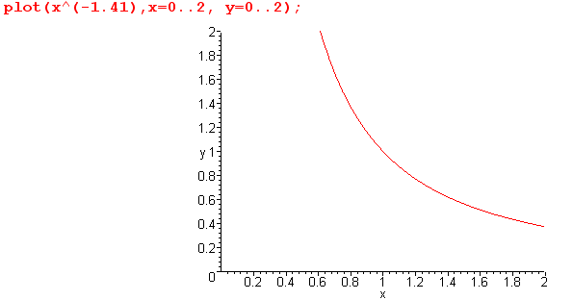

When p = p0 we have v = v0 of course, so the curve contains the point (1,1). It happens that in absolute terms, v0 = 830 cm3/gm roughly. So this explains the author's plot Fig 1a. We are talking about a small-signal amplifier operating at its bias point, all in another world.
Now let's recap our equations so far:

ρ = ρ0 (1 + ∂ξ/∂x)-1 (1)
ρ0 ∂t2ξ = -(∂p/∂x) (2)
∂t2ξ = (∂p/∂ρ) (1 + ∂xξ)-2 ∂x2ξ (3)
p/p0 = (ρ/ρ0)γ (4)

It seems that you could now say

p = p0(ρ/ρ0)γ

dp/dρ = p0 γ (ρ/ρ0)γ-1 (1/ρ0) = γ (p0/ρ0) (ρ/ρ0)γ-1 = γ (p0/ρ0) (1 + ∂ξ/∂x)1-γ = c (1 + ∂ξ/∂x)1-γ

And this dp/dρ is the object appearing in our equation (3) that we have to do something with. You can see above that we have expressed it in terms of constants and ξ which is just what we need! Then (3) says

∂t2ξ = (∂p/∂ρ) (1 + ∂xξ)-2 ∂x2ξ

= γ (p0/ρ0) (1 + ∂ξ/∂x)1-γ (1 + ∂xξ)-2 ∂x2ξ

= γ (p0/ρ0) (1 + ∂ξ/∂x)-1-γ ∂x2ξ

∂t2ξ = c2 (1 + ∂ξ/∂x)-1-γ ∂x2ξ c ≡ γ (p0/ρ0) (5) *****

This is the "exact" adiabatic equation for plane wave motion, credited to Rayleigh.

At this point the authors discuss Lagrangian vs Eulerian coordinates. Eulerian is what you use when you talk about a "velocity field", whereas Lagrangian is for "the actual particles". In our work here, we have ξ as the actual location of the gas band so ∂tξ is the Lagrangian velocity, so we have been doing Lagrangian. The authors discount work done by others who confused ∂tξ with the Eulerian velocity field. I knew this stuff was going to be tricky.
We get a reference to a book by Lamb, Dynamical Theory of Sound, 1925. I am downloading the PDF right now from http://www.archive.org/details/dynamicaltheoryo004233mbp. Lamb has a 40 page chapter on "plane waves of sound" which I can look at later perhaps.

Now back to our Rayleigh equation:

∂t2ξ = c2 (1 + ∂ξ/∂x)-1-γ ∂x2ξ c ≡ γ (p0/ρ0) (5)

This is a very non-linear equation you would like to solve for ξ(x,t). Authors claim as of 1935 it has not been solved. If dξ/dx << 1 we can approximate

(1 + ∂ξ/∂x)-1-γ ≈ (1+a)n = 1 + na + n(n-1)a2 ... = 1 + (-1-γ)( ∂ξ/∂x)

Then we have

∂t2ξ = c2 { 1 - (γ+1)( ∂ξ/∂x) } ∂x2ξ

= c2 ∂x2ξ - (γ+1) c2 ∂ξ/∂x ∂x2ξ (7)

Now we already said dξ/dx << 1 so we could junk the entire term to get

∂t2ξ = c2 ∂x2ξ

which is our small-amplitude wave equation ! (finally). Authors say Lamb was able to solve the fancier equation in a perturbation approach where he gets the usual plane wave solution plus a harmonic correction term as shown in (8).
At this point the authors discuss the non-linearity situation and Lamb's solution and his interference of two plane waves example (a mixer!). The authors claim now to "extend" Lamb's work to another level of approximation in the perturbation theory (but they don't call it that). They present a little of their theory for doing this.
Then they describe an experiment where they are going to measure these harmonic effects! Since they were all set up to measure harmonics using their tube, they also analyzed an exponential horn which is also known to make harmonics. I thought they were going to suggest a special expo horn shape to try to cancel the harmonics generated intrinsically in the air, but they did not do that.

Now, they DO refer to ∂ξ/∂x at the top of page 163 as "the dilatation", so finally we are getting a handle on that word. Lamb does not seem to use this word in his book, strangely. The limitation ∂ξ/∂x << 1 means that you must have waves with a "long" wavelength so that ξ(x,t) varies only slowly with x. If you took a snapshot of a wave and you could actually see ξ(x,t) as a sine wave, the requirement is that the slope of that sine wave is very small, the wave is very "flat". We know that

ξ(x,t) = ξ0 sin(kx-ωt)
∂xξ(x,t) = ξ0 k cos(kx-ωt) k/ω = T/λ = 1/c

So ∂ξ/∂x << 1 means ξ0 k << 1 or ξ0(ω/c) << 1. Basically this means that for any given frequency, your sound wave amplitude has to be smaller than some amount for you to get real plane waves. Another way to think of this is from

ρ = ρ0 (1 + ∂ξ/∂x)-1 ≈ ρ0(1 - ∂ξ/∂x)

ρ - ρ0 ≈ ρ0( ∂ξ/∂x)

so that

∂ξ/∂x << 1 => (ρ-ρ0)/ρ0 << 1 NOTE: LHS is called condensation s !

so there is some limitation on the amplitude of your density wave, and of course you could convert this as well to a pressure statement:

dp/dρ = γ (p0/ρ0) (1 + ∂ξ/∂x)1-γ ≈ γ (p0/ρ0) = c2 ρ0c2 = γp0

So we roughly have dp = c2dρ so we get

dρ/ρ0 << 1 => (dp/ρ0c2) << 1 => (dp/γp0) << 1 => dp/p0 << γ

so fine, either way we need small amplitude waves!

Now finally we can untangle the comments of Calvert. We had from above

ρ = ρ0 (1 + ∂ξ/∂x)-1 (1)

ρ = ρ0 (1 + Δ)-1

where Δ is the dilatation. so solve this:

(1+Δ) = ρ0/ρ =>

Δ = ρ0/ρ - 1 = (ρ0-ρ)/ρ = [(1/v0) - (1/v)] v = (v/v0) - 1 = (v-v0)/v0 // confirming Calvert

and this last form is what the sound waves document shows. So we have this distinction

Δ = (ρ0-ρ)/ρ dilatation // positive when ρ < ρ0, rarification
s = (ρ-ρ0)/ρ0 condensation // positive when ρ > ρ0, sort of compression

When ρ ≈ ρ0, we have Δ ≈ -s, just as claimed.
So I have now derived all equations appearing on page 2 of my little "sound waves" paper:

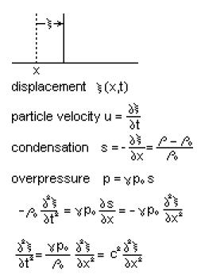

The "overpressure" thing is the only one remaining. I think he means this

overpressure = (p-p0) = γ p0 s

Is this true? Let's assume yes and go backwards

(p-p0) = γ p0(ρ-ρ0)/ρ0 => dp = γp0dρ/ρ0 => dp/p0 = γ dρ/ρ0

But this last IS approximately true because of the adiabatic law, p = p0(ρ/ρ0)γ . Above we had

dp/dρ = γ (p0/ρ0) (1 + ∂ξ/∂x)1-γ ≈ γ (p0/ρ0)

=> dp/p0 ≈ γ dρ/ρ0 QED

This author has used the exact same symbols that Calvert used I am happy to say.

Suppose we also throw in the ideal gas law pV = νRT where ν is the moles of gas. If we select our volume to be that occupied by M kg of gas (M = molecular weight), then ν = 1 mole, and our volume must then be M times the specific volume v0. So we have

p0(Mv0) = RT => (p0/ρ0) = RT/M

But γ (p0/ρ0) = c2 so we have

c2 = γ (p0/ρ0) = γ RT/M => c = sqrt(γ RT/M) // for ideal gas

Note of earlier Thuras comment. We had this earlier incarnation of our non-linear equation,

∂t2ξ = (∂p/∂ρ) (1 + ∂xξ)-2 ∂x2ξ

Suppose ∂p/∂ρ = Kρ-2. Looking at equation (1)

ρ = ρ0 (1 + ∂ξ/∂x)-1 (1)

we would then have ∂p/∂ρ = Kρ0-2 (1 + ∂ξ/∂x)2 and then our PDE would be

∂t2ξ = Kρ0-2 ∂x2ξ

which is now a linear equation and is the wave equation. Thus, ∂p/∂ρ = Kρ-2 is one "kind of gas" that would cause a linear simple exact wave equation. Note that this is the same as saying ∂p/∂v = -K since

∂p/∂v = ∂p/∂(1/ρ) = [ ∂p] / [ -ρ-2∂ρ] = -ρ2∂p/∂ρ = -ρ2 Kρ-2 = -K

But our adiabatic gas law tells us that

dp/dρ = γ (p0/ρ0) (ρ/ρ0)γ-1 = K ργ-1 = K ρ1.41-1 = K ρ0.41 for air

and thus we do NOT get our nice exact linear equation. Since γ is always positive, there is no gas which is going to cause ∂p/∂ρ = Kρ-2 in this adiabatic mode.

Summary. What are the ingredients in Rayleigh's PDE for plane sound waves?

First, we have the geometry of the picture and its underlying assumption that in a plane way some band of air is merely displaced by amount ξ AND there is also some change in ρ/p because there is a change in the thickness of the band. Perhaps this theory could be applied to an arbitrary wave and then our picture is just a little slice of space and then we are beyond just plane waves.

Second, we have F = ma applied to the shifted band.

Third, we have the adiabatic gas law that relates p and ρ

Fourth, if we agree to restrict our wave amplitude, our PDE becomes the wave equation.

Question: Why couldn't you have a displacement ξ, but no change in band thickness, which is to say, no change in ρ ?

Answer: Our very first geometry equation (1) states that ρ = ρ0 (1 + ∂ξ/∂x)-1, based on these two facts:

mass conserved definition of ξ
ρ/ρ0 = dx/δy ξ(x,t) = y(x,t) - x

If ξ(x) = constant, then ρ = ρ0 and yes, you have no change in ρ, not very interesting. If ξ(x) varies with x, which is what it must do in a non-trivial solution, then equation (1) says ρ also varies with x ! So one think to keep in mind: if you solve your problem for ξ(x,t), then you at once know ρ(x,t) from Eq (1). One determines the other. To go from ρ to ξ you would need to do some kind of integration, so that is the harder direction. Best to solve first for ξ ! Then you know ρ, and from adiabatic you know p !

Daddy Reif mentions the sound wave equation on page 195 in problems 5.8 and 5.9 and nowhere else. He comments that normal sound vibrations are much faster than diffusion/heatflow time constants, and that is why you can have the wave in the first place.

Baby Reif mentions sound in one paragraph on p 281 after he has done the adiabatic thing, but does not state the wave equation. He does note that by measuring sound velocity, you can measure γ .

Crawford (Waves) has a good section pp 165-169. He first presents Newton's derivation of the wave equation thinking of a tube of air as a mass on a spring and finding the spring constant from F = ma. Then Newton used the constant temperature pv = nRT law (Boyle) instead of the adiabatic law, and thus got the wrong sound velocity as if γ = 1. Using adiabatic corrects this result. So the point is that you can come up with an implied wave equation in a simple way by this argument. Or at least an oscillating spring. Crawford also examines in detail those time constants versus mean free path and arrives at a condition for adiabatic to be valid. He notes that 20 kHz is λ = 1.6 cm which is still >> 10-5 cm, his adiabatic limit.

Lucht. What did I do wrong in my little whiteboard session?

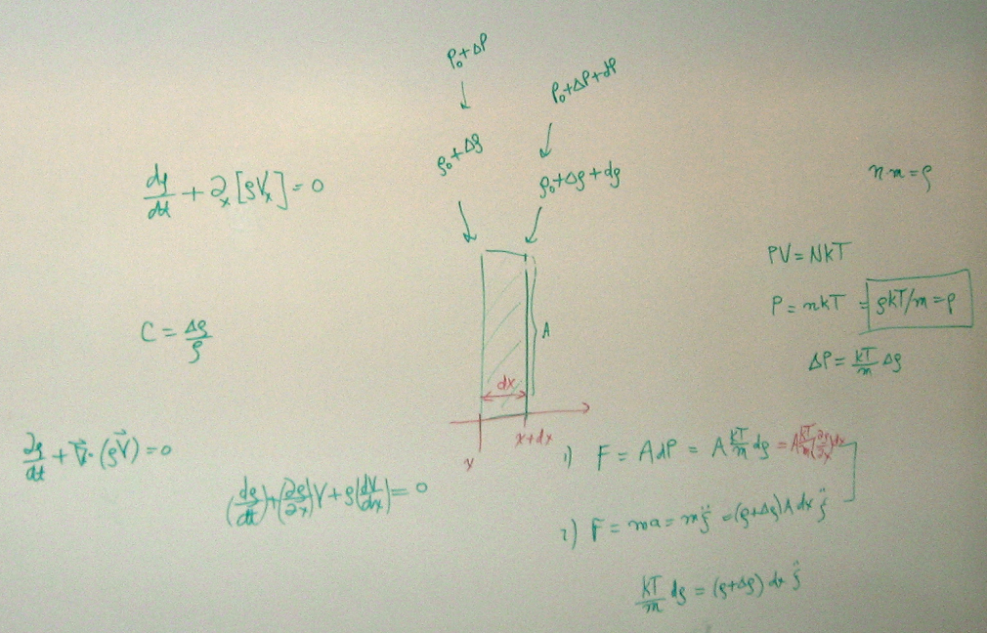

In my "analysis", I considered just a single slice of the plane wave which is fine. As you move to the right an amount dx, ρ will change by some amount, correct. On the right I use the ideal gas law to relate p and ρ. This is the constant temperature thing instead of adiabatic thing, but OK, I am in good company with Newton. This just means I have γ = 1. Then lower right I try to write F = ma. Here I write a ξ displacement coordinate, but I fail to relate that to the picture! What was I thinking ξ was? What exactly is being "displaced" in my picture? This is where I dropped the ball. This is why the Thuras picture is so much better, because it implies an actual model for what is happening, a band is being displaced to a new band by amount ξ. By not having ξ anywhere, my analysis was doomed. Just flailing. Further, from F = ma I was obtaining a time derivative which is indeed in the wave equation (though ξ is still undefined), but I was unable to come up with any ∂x2ξ term. In retrospect, in my F = ma shown in 1) in the photo, I had F = A kT/m * dρ which I could write as A kT/m * dρ/dx dx . The dx's could cancel in F = ma and then I have this (dρ/dx) factor sitting there. In the Thuras analysis, we have ρ(x) = ρ0 (1 + ∂ξ/∂x)-1 and the of course (dρ/dx) = - ρ0 (1 + ∂ξ/∂x)-2 ∂x2ξ ≈ - ρ0∂x2ξ and THAT is where the second spatial derivative comes from. But I had no chance since I did not define ξ at all.
On the left side of the whiteboard I was messing with the equation of continuity relating mass density ρ to mass current J = ρV . I guess I was trying to apply continuity to my single slice. As dt goes by, presumably yes ρ changes, so there is some ∂ρ/∂t. If ρ were constant in space, I would get the heat equation fluid flow business with potential theory, but ρ is NOT a constant in sound physics. So continuity just provides a relation between ρ and the velocity field V. Both ρ and V are unknown, so I don't think you could solve anything just using this equation, you still need some form of F = ma. But F = ma is a Lagrangian thing, so hard to imagine how you would bail this all out.
Somehow there is a connection to my fluid dynamics book, but that book's discussion is immensely complicated and I am just not ready for it now. Luckily the web provided Thuras and Calvert.

Particle Velocity.

Calvert defines u = ∂ξ/dt and claims we need u << c to have the wave equation. Can I show that? Go back to this

ξ(x,t) = ξ0 sin(kx-ωt)
∂xξ(x,t) = ξ0 k cos(kx-ωt) k/ω = T/λ = 1/c

and we can now add

u = ∂tξ(x,t) = ξ0 (-ω) cos(kx-ωt)

We already said w need ∂xξ << 1 which means ξ0 k << 1 which means ξ0 (ω/c) << 1 or ξ0ω << c. But this then says u << c and that is it! QED.

